Manuscript Submission Template
FIRST Author¹, SECOND Author², THIRD Author^{3*}
¹ Department, University Name, City, Country
²Affiliation
³Affiliation
*Corresponding Author: Name, Corresponding address, State ZIP/Zone, Country; email address

ABSTRACT
Use the word “ABSTRACT” as the title, boldface type, centered relative to the column, fully capitalized. The length of the abstract should be 200 words or less. It should briefly state the purpose, method and results of the paper. All manuscripts must be in English.

Keywords: Please use about 3 to 5 keywords; capitalize the first letter; separated by semi-colon.

1. Introduction
Please follow the steps outlined below when submitting your final draft to the EnPress Publisher. These guidelines include complete descriptions of the fonts, spacing, and related information for producing your manuscript.

2. Main Title
2.1 Sub-heading
Capitalize the first letter. Please initially capitalize only the first word in other titles, including section titles and first, second, and third-order headings.
2.1.1 Sub-subheading
Sub-subheadings should not be typeset in italics, with only the first word capitalized (see example above).

3. Tables
Place tables as close as possible to the text they refer to and aligned center. A table is labeled Table and given a number (e.g., Table 1. Sample Datasheet) it should be numbered consecutively, and the title shall be displayed above the table, aligned center and bold face, no additional blank line.
In cases where the tables need to be extended over to the second page, the continuation of the table should be preceded by a caption, e.g., “Table 1 (Continued)”. Footnotes in tables should be written in superscript lowercase letters and placed below the table.

Table 1. Table label

A | B | C | D | E
1 | 23 | 45 | 67 | 89
4. Figures
Place figures as close as possible to the text they refer to and aligned center. Photos, graphs, charts or diagram should be labeled Figure (do not abbreviate), and assigned a number consecutively (Figure 1). The title should appear underneath the figure, aligned center, no additional blank line.

For example:
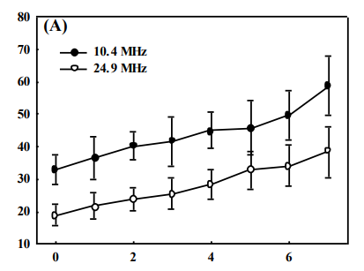
Figure 1. Figure label

5. Equations
Including symbols and equations in the text, the variable name and style must be consistent with those in the equations. Equations should be indented at the left margin and numbered at the right margin, equation number is enclosed with open and close parenthesis (). Do not put the equations inside the inserted table.

For example:

(1)

Conflict of Interest
Declaration of conflict of interest. If no conflict of interest, please state that: The authors declare that they have no conflict of interest.
Acknowledgments
The acknowledgments section is not required, and it may appear just before the references if possible. It is the section where the authors may credit others for their guidance or help in writing the manuscript. Funding sources or sponsorship information may be included here if possible.

- This is the Appendix
Supplementary materials that are excluded in the main body of the paper may be included in the appendices. These include derivations of equations and details of algorithms. Appendices should be used only when advanced technical details are essential to the paper.

References
List and number all bibliographical references that has important contribution on the paper, (if possible, limit to 30, which only are necessary citations are recommended). When referenced in the text, enclose the citation number in square brackets, for example ^{[1]}. (See examples below)

1) Journal Article
Format as following: numerical order, double blank, name (family name, abbreviation of first name; use et al. if more than three authors) point, title of the cited article, journal title, year of publication, semi-colon, volume number, issue number with brackets, colon, initial and last page number.
For example:
1. Tom C, John EF, Matt GH, et al. Study on persistent organic pollutants in Southern Town. Journal of Smart Construction 2013; 1(2): 5–8.
2) Book
Format as following: the author's name, book title, publisher, city of publication, year of publication, and initial and last page number.
For example:
1. Carr I, Kidner R. Statutes and conventions on international trade law (4th ed.). London: Cavendish, 2009. 11–14.

