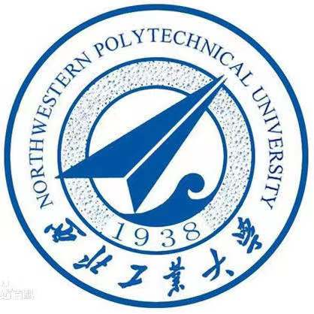

John Wiredu.

Management Science and Engineering,

School of Management, Northwestern Polytechnical University, Xi’an China.

May 11TH, 2023.

Stimulating environmental performance through green human resource practice: Does green transformational leadership matter?

John Wiredu,

1School of Management, Northwestern Polytechnical University, Xi’an China.

johnwiredu50@gmail.com

\*Correspondence: [johnwiredu50@gmail.com](mailto:johnwiredu50@gmail.com) (+86 15619219016)

The Editor, Management,

Dear Editor-in-Chief / Deputy Editor,

I/We wish to submit an original research article entitled "Stimulating environmental performance through green human resource practice: Does green transformational leadership matter?” for consideration by Journal of Infrastructure, Policy and Development.

In this paper, I/we made the conclusion below based on our findings and we believe that this manuscript is appropriate for publication by Journal of Infrastructure, Policy and Development.

Businesses are essential in nations' economic development, green practice, and environmental performance, particularly in emerging countries. Such economic development needs environmental-friendly business practices to attain higher environmental performance goals of businesses. Nevertheless, a plethora of studies centered on the direct effects of environmental management initiatives (EMI) and green innovation practices (GIP) on environmental performance (EP). Still, the direct and indirect impacts of green human resource practices (GHRPs), green transformational leadership (GTL), and other constructs were ignored. This study analyzes the direct and indirect relationships of GHRPs, EMI, and GIP toward improving EP. In addition, the study examines the moderation role of GTL between GHRPs and EP under the theoretical framework of ability, motivation, and opportunity (AMO) theory. Empirically, this present study utilized a survey method to assemble data from 535 business entities in South Africa. The analysis showed that GHRPs directly and significantly influenced EMI, GIP, and EP. EMI and GIP also directly and significantly influenced EP. Finally, GTL significantly affects the interplay between GHRPs and EP. This study's results provide a managerial and theoretical contribution to how GHRPs, EMI, GIP, and GTL facilitate a corporate EP. The study emphasizes the need for businesses and managers to apply green human resource policies to make employees more committed to environmental sustainability, promoting EP in the long term.

I/We have no conflicts of interest to disclose.

I/We confirm that this work is original and has not been published elsewhere, nor is it currently under consideration for publication elsewhere.

Thank you for your consideration of this manuscript.

Sincerely,

John Wiredu.

(Corresponding author)

aShaanxi-Xi’an, China

aTelephone: +86 15619219016

aPrimary Email: [johnwiredu50@gmail.com](mailto:johnwiredu50@gmail.com) (ORCID: 0000-0003-3980-1289)