Article
Integrated use of a numerical model and remote sensing for oil spill monitoring in Balikpapan Bay, Indonesia
Supplementary materials
Table S1. Model parameters.
Parameter | Sources | Link
Water depth | Bathymetry from CMap Norway | https://www.c-map.com/
Coastline | Basemap from Indonesia Geospatial Portal | https://tanahair.indonesia.go.id/
Temperature;  salinity | World Ocean Atlas (WOA) & Conductivity, Temperature & Depth (CTD) in-situ Observation | https://www.ncei.noaa.gov/products/world-ocean-atlas/
Rainfall;  sea surface wind;  evapotranspiration;  wave radiation | ERA-Interim | https://apps.ecmwf.int/datasets/data/interim-full-daily/levtype=sfc/
Oil properties | PERTAMINA Laboratory
Table S2. Primary data input.
Position of oil leakage | Parameter | Value | Unit | Remark
Coordinate | Longitude | 116°47'22.17"E | Lat/Long WGS84 | Coordinates of pipe breakage (UTM50S: 476581.14, 9862304.51)
 | Latitude | 1°14'44.75"S
Pipeline Depth | From Sea Surface | 28 | meter | -
Pipe Dimension | Diameter | 20 | inch | -
Flow of Oil in Pipeline | Discharge | 1200 | m³/hr | -
Time and date of oil leakage | Parameter | Value | Unit | Remark
Time Event | Time | 1: 20 | UTC +8 | -
 | Date | 31-Mar-2018 | AD (Anno Domini)
Duration of oil leakage | Parameter | Value | Unit | Remark
 | Time Begin | 23:30 | UTC +8 | -
 | Date Begin | 30-Mar-2018 | AD (Anno Domini)
 | Ending Time | 11:10 | UTC +8 | The time all pumps were turned off: April 1, 2018 - 11:10 WITA. Whereas starting from March 31, 2018, one pump was operational. Normal operation is with two pumps.
 | Ending Date | 01-Apr-2018 | AD (Anno Domini)
 | Estimated oil volume | 2402.97 | m³
Oil type of oil leakage | Parameter | Value | Unit | Remark
General | Type | Crude Oil | Type of Oil | -
Physical | Specific Gravity | 0.8265 | (kg in 1 liter oil) | Specific Gravity @60/60F
Physical | Density at Standard Temperature | 826.5 | (kg/m³) | -

Table S2. (Continued).
Rate of oil leakage | Parameter | Value | Unit | Remark
Flow Rate | (Unit Volume per Time) or (Unit Mass per Time) | 1100 | m³/hr | -
Oil characteristic of oil leakage | Parameter | Value | Unit | Remark
Oil Fraction 1 | Mass of volatile oil fractions (weight below 160 g/mol, boling point well below 300 ℃) | 59.16 | vol% | Consisting of gas components (light end), light naphtha, heavy naphtha, kerosene, light gasoil, and part of heavy gasoil.
Oil Fraction 2 | Mass of heavy oil fractions (weight above 160 g/mol, boling point above 300 ℃) | 40.84 | vol% | Calculated, derived from the remaining fraction other than oil fraction 1
Oil Fraction 3 | Wax mass in oil (conservative) | 8.01 | wt% | Total wax content di whole crude
Oil Fraction 4 | Asphaltene mass content in oil (conservative) | 0.31 | wt% | Total asphaltene di whole crude
 | Water fraction of oil | 0.4 | vol% | Data analysis of crude CDU IV for sediment and water parameters
Oil clean up | Parameter | Value | Unit | Remark
Booms or skimmers or dispersants or in-situ burning or beach clean up | Effectiveness of Oil Clean Up | 1.17 | (%) | -
Table S3. Model assumption.
No | Name | Description | Unit | Value
1 | EvaporationType | Select between a simple, time depended (=1, default) or detailed (=0) evaporation formula | switch (0/1) | 1
2 | Sc | Detailed Evaporation: Schmidt number | dimensionless | 2.7
3 | MW | Detailed Evaporation: Average molecular weight of volatile fraction of oil | g/mol | 117
4 | Pvp | Detailed Evaporation: Vapor pressure of volatile fraction | atm. | 0.002
5 | Simple_Evap_type | Simple Evaporation: select logarithmic or quadratic oil type (logarithmic = 0, quadratic = 1) | switch (0/1) | 0
6 | evap180 | Simple evaporation formulation: distillation percentage (by weight) at 180 ℃ | dimensionless | 26
7 | evapA | Simple evaporation formulation, 1st oil specific constant | dimensionless | 2.67
8 | evapB | Simple evaporation formulation, 2nd oil specific constant for temperature dependency | dimensionless | 0.06
9 | hterm | Spreading: Terminal thickness | m | 0.0001
10 | kbiodv | Biodegradation volatile fraction: Decay rate | per day | 0.005
11 | kbiodh | Biodegradation heavy fraction: Decay rate | per day | 0
12 | MaxWater_Fract | Emulsification: Maximum water fraction | dimensionless | 0.75
13 | Kao | Emulsification: Constant Kao equal 3.3 at 293 °K | dimensionless | 3.3
14 | Kaw | Emulsification: Constant Kaw equal 200 at 293 °K | dimensionless | 200
15 | kem | Emulsification: emulsion rate | s/m² | 1.00E-06
16 | densL | Buoyancy: Density of original oil, volatile fraction (20 ℃) | kg/m³ | 755
Table S3. (Continued).
No | Name | Description | Unit | Value
17 | densH | Buoyancy: Density of original oil, heavy fraction (20 ℃) | kg/m³ | 831
18 | Cwsatv | Water solubility: volatile fraction | dimensionless | 2.00E-05
19 | Cwsath | Water solubility: heavy fraction | dimensionless | 2.00E-07
20 | ktempv | Volumetric temperature expansion coefficient volatile oil fraction | 1/℃ | 0.0007
21 | ktemph | Volumetric temperature expansion coefficient heavy oil fraction | 1/℃ | 0.0007
22 | kphotv | Photooxidation volatile fraction: Decay rate at 100 watt/m² | per day | 0
23 | kphoth | Photooxidation heavy fraction: Decay rate at 100 watt/m² | per day | 0
24 | eta | Photooxidation: Light extinction coefficient | 1/m | 1
25 | kdisl | Dissolution: Rate, light fraction | per day | 0.4
26 | kdish | Dissolution: Rate, heavy fraction | per day | 0.4
27 | wspdi | Vertical dispersion: Wind speed for initiation of wave breaking | m/s | 5
28 | E | Vertical dispersion: wave energy dissipation rate per unit volume | J/m³/s | 1000
29 | minSurfDist | Max distance below surface to belong to surface amount | m | 0.05
30 | minBotDist | Distance above bed to belong to bottom amount | m | 0.05
31 | Mooney_K | Mooney constant in the viscosity-equation | dimensionless | 0.7
32 | ViscosityT0 | Dynamic oil viscosity at reference temperature | cP | 6
33 | Viscosity_temp | Reference temperature for dynamic oil viscosity | ℃ | 15
34 | Viscosity_coef | Coefficient for exponential temperature dependency of viscosity | dimensionless | −0.111
35 | AreaGrowth | Oil Area growth rate constant | per second | 150
36 | RemoveMass_Threshold | Particles with a total oil mass below this threshold will be removed | kg | 0.001
37 | Layer_start | Depth where extra output layer starts | m | 0
38 | Layer_end | Depth where extra output layer ends | m | 10
39 | Enable_Dispersion | Vertical dispersion: on-off switch (0 = off, 1 = on) | switch (0/1) | 1
40 | Enable_EVAP | Evaporation: on-off switch (1 = on, 0 = off) | switch (0/1) | 1
41 | Enable_BIOD | Biodegradation: on-off switch (1 = on, 0 = off) | switch (0/1) | 1
42 | Enable_PHOT | Photo-oxidation: on-off switch (1 = on, 0 = off) | switch (0/1) | 1
43 | Enable_Diss_s | Surface dissolution: on-off switch (1 = on, 0 = off) | switch (0/1) | 1
44 | Enable_Diss_wc | Water column dissolution: on-off switch (1 = on, 0 = off) | switch (0/1) | 1
45 | Enable_Wateruptake | Water uptake: on-off switch (1 = on, 0 = off) | switch (0/1) | 1
46 | Enable_Waterrelease | Water release: on-off switch (1 = on, 0 = off) | switch (0/1) | 1
47 | Enable_Diameterchange | Droplet diameter change: on-off switch (1 = on, 0 = off) | switch (0/1) | 1
48 | Enable_Areachange | Area change: on-off switch (1 = on, 0 = off) | switch (0/1) | 1
49 | Gas Constant | Gas Constant | Built-in
50 | Time Step | Time Step | Atm m²/mol K | 8.21E-05
51 | Dynamic Viscosity | Dynamic viscosity of water at 20 ℃ | cP | 1.002

Table S4. Secondary model forcing.
No | Description | Type | Value | Unit
1 | Horizontal drift speed | Built-in
2 | Horizontal drift direction | Built-in
3 | Vertical drift speed | Constant | 0 | m/s
4 | Wind speed | Built-in
5 | Water Temperature | Constant | 30.19564 | °C
6 | Density of water | Constant | 1016.997 | kg/m³
7 | Solar radiation | TS file | Varying | watt/m²
8 | Wave height | Constant | 0.289455 | m
9 | Wave period | Constant | 5.5 | s
10 | Area map with probability of a particle getting absorbed when beached | Constant | 0 | probability
11 | Area map with probability of a particle to not move | Constant | 0 | probability
12 | Area map of activity for dispersant | Constant | 1.17 | dimensionless
Table S5. In-situ measurement of water level.
Station | WL in Spring tide [m] |  | WL in Neap tide [m] |  | The tidal range [m]
 | Maximum | Minimum | Maximum | Minimum | Full moon tide | Neap tide
TD1 | 1.59 | −1.55 | 0.41 | −0.40 | 3.02 | 0.81
TD2 | 1.54 | −1.48 | 0.43 | −0.51 | 3.02 | 0.94
Table S6. The simulated concentration of stranded oil on C1–C4 transect.
Transect | Oil concentration stranded [mg/kg]
 | Minimum | Maximum | Average
C1 | 3133 | 17,475 | 6890
C2 | 1001 | 31,555 | 4663
C3 | 3885 | 78,056 | 33,372
C4 | 6060 | 29,634 | 17,838
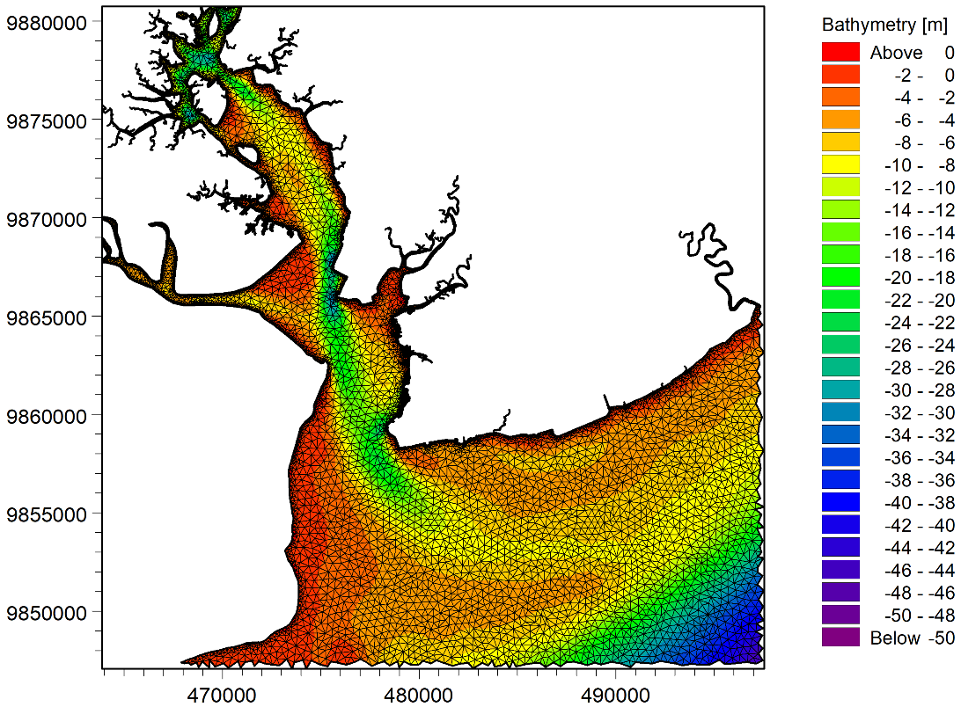
Figure S1. The computational domain utilized for the numerical simulations.

