Innovative piggery waste resources reusing-direct land application

Tzung- Yuh Yeh¹, Hong-Giang Hoang² Min-Hao Wu1, K F Chen3, Y P Peng4
¹ Department of Civil and Environmental Engineering, National University of Kaohsiung, Kaohsiung city, Taiwan
² Institute of Marine Science and Technology, National Kaohsiung University of Science and Technology, Kaohsiung city, Taiwan
3. Department of civil engineering, National Chi Nan University
4. Department of environmental engineering. Tunghai University
Correspondence to:
Prof. Tzung- Yuh Yeh
National University of Kaohsiung
Department of Civil and Environmental Engineering
700, Kaohsiung University Rd., Nanzih District, Kaohsiung 811, Taiwan, R.O.C.
Tel: 886-7-591-9536 Fax: 886-7-591-9376
E-mail: tyyeh@nuk.edu.tw

Abstract
One of the main sources of water pollution in Taiwan is piggery waste. With the major pollutants such as odors, BOD, TN and TS, waste from the piggery industry has been seriously affecting the environment in Taiwan. However, if this amount of waste is properly treated, it will bring great benefits and can be considered as a resource. Generally, wastewater from the piggery industry is treated in three stages: liquid soil, anaerobic digestion and then aerobic treatment. However, this process is difficult due to high cost and difficult operation. Therefore, a feasible method was to establish a centralized methane production facility for the treatment of piggery industrial waste. The products after treated like methane and fertilize are utilized as clean and environmentally friendly products. Methane can be used for cooking or electricity generation. This is a new direction suitable for sustainable development. Keywords: Piggery waste, manure, soil

Introduction
Currently, there are 5,539,130 capita pigs in Taiwan which located in pintung, yulin, chunghwa, tainan, chayi, kaohsiunf townships. The types of piggery industries are enormously large and congested. The qualities of piggery wastewater are high SS, high organic matters, and high ammonium nitrogen. In addition, the piggery wastewater has strong odor and quality fluctuated. Piggery wastewaters encompass high nutrient loading. If improper managed, it will pollute aquatic environment and induce serious eutrophication. The smell piggery waste will deteriorate living standard and affect human health. Anaerobic biological treatment processes dealing with high organic loading piggery wastewater possess low energy consumption, methane resource recovery, high treatment capability, low sludge generation, high toxic substance endurance. It has become the popular research topic in water industries (Su et al., 2003).
On average, each pig produces about 3.8 kg of manure per day. This amount of manure contains about 15g BOD, 20g TN and 375g volatile suspended solid (VS). In addition, waste from one pig can produce 0.1 cubic meters of methane per day. In Taiwan, there are more than 8,100 pig farms with more than 5,000 pigs, so an average of 750 kg of BOD, 100 kg of TN, 1,875 kg of VS and 500 cubic meters of methane can be generated per day. If the manure is not properly collected and treated, the pollutants will enter and seriously affect the surrounding environment.
To manage the pollution from the piggery industries, Taiwan has been collecting water pollution charges since 2017. The quality of wastewater from the piggery industries is controlled by the Effluent standard. Accordingly, the piggery industries need to report the quantity and quality of their effluent to the environmental regulators. If they do not report, report false or breach of standard they may be fined from 60,000NT - 600,000NT, serious cases can be fined up to 20,000,000 NT
Taiwan swine industries are condense and large scale implementation located in southern part of the island. The waste generated from industries are high SS, organic pollutants, and ammonium nitrogen imposes adverse effect on the aquatic ecosystem. Currently, three stage anaerobic wastewater treatment processes are commonly used. Taiwan has started to collect wastewater discharge fees. Agricultural government agencies intended to encourage swine industries to reduce their pollution discharge loadings by propagate this new policy. Swine industries waste is a resource not junk. To use their fertilizing components can benefit agriculture operation. Cu and Zn are concerns of soil contamination. Integrated phytoremediation can be employed to removal Cu, Zn and energy plants, sun flowers, can be extracted oil to produce energy. This study mandates to swine industries pollution environment removal impact and additionally to create energy.
In Taiwan, a novel policy intended to remediate Cu Zn tainted paddy fields by launch flowers sightseeing festivals. The benefits regarding this approach will be aestheticism, environmental tourist, and pollution remediation.
Three stages piggery waste treatment processes
The process of wastewater treatment of the piggery industries has three main stages. They are soil liquid separation, anaerobic digestion and aerobic treatment.
Soil liquid separation: The primary function of solid liquid separation is scum generation reducing and treatment capacity levying. It separates manure and pie which can lessen treatment laboring significantly. Generally speaking, 15－30% BOD removal and 50% SS removal. The screen is 0.5 mm first following by 0.3 mm. The second screen has trustworthy treatment capability.
Anaerobic fermentation: Anaerobic fermentation can degrade complex organic substance into simple CH4, CO2 under anoxic condition. The advantages of anaerobic fermentation are low sludge generation, methane resource recovery, high organic loading endurance, great treated water production, save oxygen, killing pathogen and virus. However, the disadvantages are ambient temperature limitation, sluggish methanogen microorganism growth, high detention time. Anaerobic fermentation can divide into acid production and methane generation. The first stage is facultative or anaerobic microorganism converting protein, carbohydrate, and lipid into organic acids such as acetic acid. The second stage subsequently converts organic acid and alcohol into CH4 and CO2. The control environment factors including temperature, pH, toxic substances, mixing, and sludge recycling, and methane production .
Aerobic treatment: Activated sludge process is using aerobic microorganisms including bacteria, fungi, protozoa, and rotifer adsorb, degrade, and treat dissolve and micro particular substances. The mixed liquors are mixed cultures bioflocs.
There are five stages including primary settling basin, aerated tank, second sedimentation basin, recycling sludge and wasted sludge. Piggery toilet can be equipped in front of three stage treatment processes. Piggery toilet can lessen water consumption, increase carbon nitrogen ratio, and enhance methane production. Methane can be reused as power, heat sources, and fuel. The treatment of wastewater from piggery industries in Taiwan is not really attention. Costs and difficulties in operating the system is the limitations that made the treatment of wastewater from piggery industries in Taiwan not widely available.
Case study
Danish case study
Piggery manure and food industry organic wastes were used to produce methane. The methane production rate was 13,000 m3/d, which 15.5％ used for digester heating and 2.5％ used for plant electricity supply. The remaining 82% methane was piped to local electricity generation and these sold to the national electricity network. Total monetary production was 104,000 $US. Pigger liquid waste was provided to farm itself and generation 14,000 $US (Su et al., 2003).
Chinese case study
Poultry waste was employed to produce methane. The methane annual production rate was 7,000,000 m3 and generated 14,000,000 electricity. The solid phase organic fertilizer 6,600 tons and liquid waste 70,000 tons can fulfill farm fertilizer need. The major profit include electricity sold and CO2 emission reduction.
A. Electricity venues
The electricity worth 0.38 NMB/degree and national compensation 0.25 NMB/ degree added to 0.63 NMB/degree. The annual profit was 8,820,00 NMB.
B. CO2 emission reduction
Based on CDM (Clean Development Mechanism) emission reduction 1 ton CO2 worth 9 UN dollar. Annual CO2 90,000 tons and 8,000,000 RMB.
Enforcement policy
Encourage using of manure from the piggery industries for the field if their quality is suitable with standard
Waste management policies are minimized if strictly enforce the regulations governing waste control
Apply green technology and clean development mechanism to boost the piggery industries
Action plans
Apply anaerobic technology to treat wastewater from the piggery industries to produce fertilizer and use for farmland.
Promote policies through the organization of workshops or revision of existing regulations
Taiwan EPA does not accept the recurrence of polluting pig farms
Focus on controlling environmental pollution in seriously polluted areas
Future challenge
The piggery industries with their pollution bring many challenges in the future. The first, odor problem is a big challenge. In addition, if the business can not handle on the spot, the cost of transporting waste to the treatment place will be very expensive. Piggery farmer can not afford to do it. Therefore, a feasible method is to build waste treatment systems at farms for treating waste. Post-treatment products such as methane or fertilizers can be used as clean and environmentally friendly products
Conclusion
The issue of environmental pollution arising from the piggery industries is gaining much attention in Taiwan. Waste generated from this industry is considered as a major source of pollution in the water environment in Taiwan. However, if properly treated, this waste source will be view as a resource. One fessible method proposed is the treatment of waste from the piggery industrie by anaerobic treatment. This method offers many benefits in utilizing the products created after the treatment. Methane can be used as a clean fuel for cooking or used to generate electricity. Fertilizer is used directly for agriculture. This approach is aimed at the development of a clean piggery industry and a sustainable agriculture
Acknowledgement
The authors would like to thank all colleagues and students who contributed to this study. Thanks for commenting on an (early) draft of the work/part of the work.
This work was supported through EPA. We would like to thank two anonymous (unknown) reviewers and the editor for their comments. The errors idiocies and inconsistencies remain my own.

Reference
Su JJ, Liu BY and Chang YC (2003) Emission of greenhouse gas from livestock wa 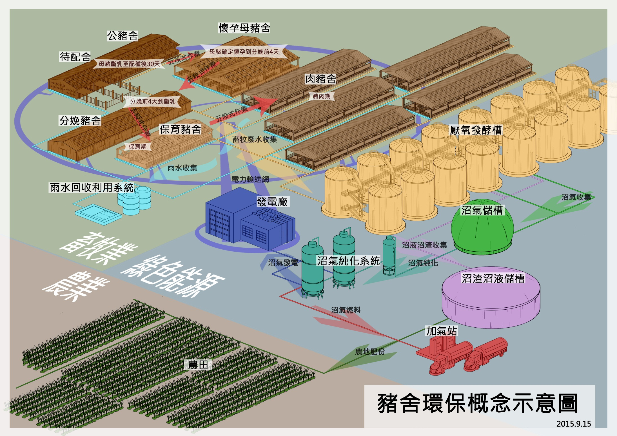
Ideal layout of pif farm industry
