**A review on metal-organic framework: synthesis, properties and application**

**CharuArora1, Sanju Soni1, Parmendra Kumar Bajpai2**

1Department of Chemistry, Guru GhasidasVishwavidyalaya, Bilaspur, C.G. 495009, India.

2Department of Pure and Applied Physics, Guru GhasidasVishwavidyalaya, Bilaspur, C.G. 495009, India.

**ABSTRACT**

Metal organic framework is a class of hybrid network of supramolecular solid materials comprised of a large number of inorganic and organic linkers all bounded to metal ions in a well organised fashion. This type of compounds possess a greater surface area with an advantage of changing pore sizes, diversified and beautiful structure which withdrew an intense interest in this field. In the present review article structural aspects; classification; methods of synthesis; various factors affecting the synthesis and stability; properties and applications have been discussed. Recent advances in the field and new directions to explore the future scope and applications of MOFs have been incorporated to provide current status of the field.tr

***Keywords****:* Metal organic framework;nanoporous material; drug delivery; gas sensor;

secondary building unit.

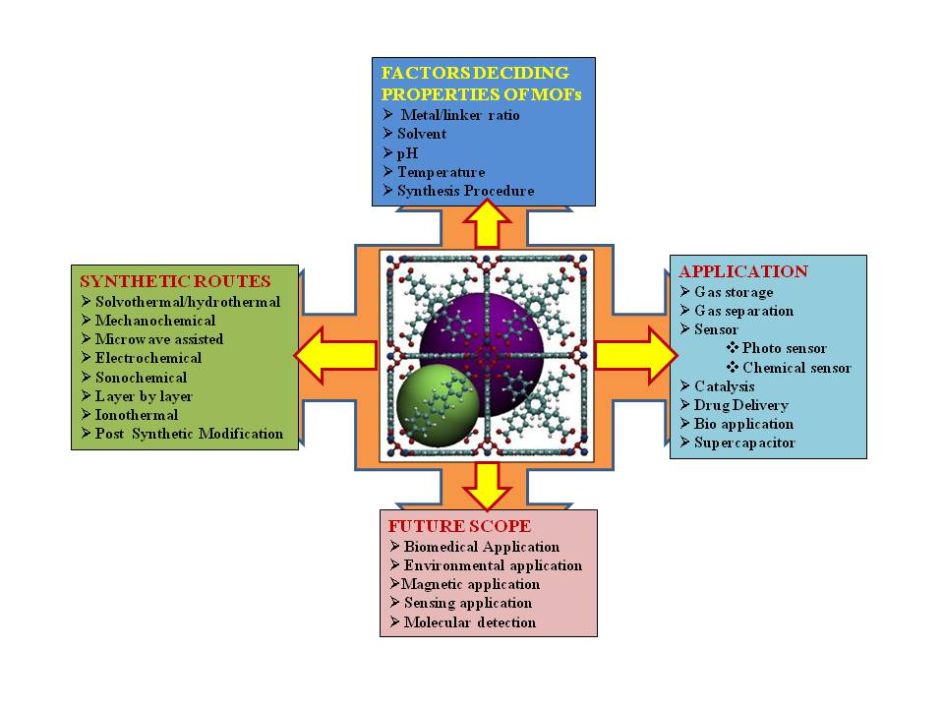

**1. Introduction**

Metal-organic framework (MOF) is a promising class of materials composed of metal centres or clusters and organic linkers. These are porous crystalline materials in which metal is locked into a position to produce rigid and porous geometry and connected through different organic groups. Due to structural flexibility, large surface area andtailorable pore size, MOFs have wide applications in field of gas adsorption and storage, separation, catalysis, sensing, molecular recognition, drug delivery, non-linear optics, luminescenceetc[1-12].Due to three dimensional tuneable porous channels, MOFs are useful materials for storage, separation or conversion of molecules on the basis of dimension.Generally, MOFs are related to the general class of co-ordination polymers. However, MOFs are more specific than co-ordination polymers for 2D or 3D crystallized networks with porous structure. Thus these are also termed as porous coordination polymer (PCP)[13,14].Although, several review articles on metal-organic frameworks have been published previously, however, recent advances including the contributions of some Indian research groups, such as Banerjee et al,Ghosh et al, and Kumar etc. necessitates further review on this topic.The present paper comprehensively reviewed the methods of synthesis, properties and applications of MOFs based on reportedliterature.Recent advances and new foundations, direction for further exploring MOFs for their applications as well as critical analysis of the research have been incorporated so as to provide the current status of the field.

**2. Structural aspects**

**2.1 Primary building units**

The metal ions (connectors) connecting the organic polymers which are linkers are basic primary units that result into porous three dimension structure MOFs. Thus,themetal ions and organic compounds used in the formation of metal-organic frameworks are the “Primary Building Units”. Commonly, metal ions offirst row transition series such as Cr3+, Fe3+, Co2+, Zn2+ are used as connectors in the formation of MOFs[15-17]. Some alkali metal ions[18,19], alkaline-earth metal ions[20-22] and rare earth metal ions[23-27] are also used as a metal connector inthesynthesis of MOFs. Nitrate, acetate, sulphate, chloride and oxide of metals are used as precursor for preparing MOFs in most of the synthesis routes.However,in electrochemical synthesis of MOFs metal rods are used.

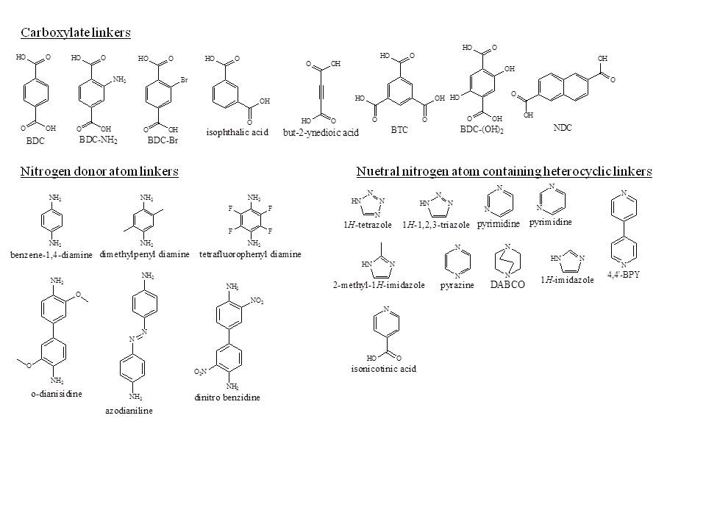

**Figure 1.** Some Linkers used in synthesis of MOFs

Organic linkers, through which the metal ions or nodes are connected, generally contain functional groups that are capable of forming coordination bonds such as carboxylate, phosphate, sulfonate, amine, nitrile etc. some examples of organic linkers are shown in Figure 1.

**2.2 Secondary building units (SBUs)**

In MOFs, organic linkers are connected through Metal-oxygen-carbon clusters, instead of metal ions alone. These metal-oxygen-carbon clusters are referred as “Secondary Building Units” (SBUs). SBUs have intrinsic geometric properties, which facilitate MOF’s topology[28]. Some SBUs are shown in Figure. 2.

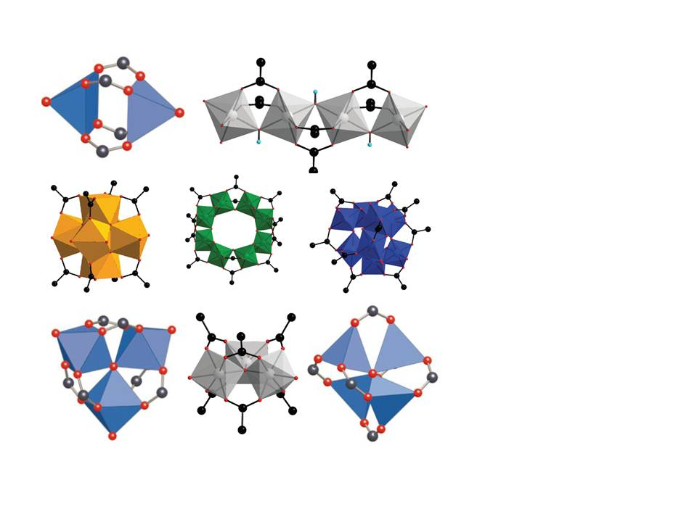

**Figure 2.** Some secondary building units (SBUs)

**2.3 Classification of metal-organic frameworks**

On the basis of structural features, MOFs have beenclassified[29] in following groups

1. **Rigid framework**s:These are stable and robust porous frameworks and retain their porous framework on adsorption or desorption of guest molecules. These MOFs are applicable in molecular sieving[30].
2. **Flexible/dynamic frameworks:** Flexible frameworksshowanutmost change in shape on insertion or removal of guest particles and also affected by external factors such as pressure, temperature. Dynamic MOFs showachangeinframeworkonremoval of solvent molecules but retain their porous structure on adsorption of gas molecules at high pressure[4]. MIL-5[31,32], MIL-8[33] and SNU-M10[34]are some MOFs that exhibit breathing effect during adsorption and desorption. In breathing MOFs[35] there is a severe change in unit cell volume (pore volume) on adsorption/desorption of guest molecules. Different types of flexibility modes are identified and reviewed as shown in Figure 3.



**Figure 3.** Classification of different flexibility modes of MOFs

1. **Open metal site**: Performance of MOFs can be enhanced by the presence of open metal site. Presence of water in open metal site MOFs enhances the CO2 capture ability of the MOFs. For example, HKUST-1 [(Cu)3(btc)2] which has an open metal site structure and consists of paddlewheel units Cu2(COO-) connected through btc3- ligands, exhibits a significant increase in CO2 adsorption when it contains 4 wt.% water[36].
2. **Surface functionalized framework**:Adsorption ability of MOFs can be enhanced by grafting functional groups onto the surface of the MOFs. Functional groups having a high affinity for CO2 (e.g. arylamine[37], alkylamine[38], hydroxyl[39]) have been reported to enhance the capacity and selectivity of MOFs for CO2 adsorption when these functional groups are grafted onto the surface oftheporous framework through either ligand modification or coordination to unsaturated metal centre.

**3. Synthesis ofMOFs**

As discussed earlier, MOFs consists of two major components, metal ion and organic linkers or bridging ligands. Conventionally, MOFs are prepared by combining metal ions and organic linkers under mild conditions in order to get a crystalline and porous network. This is termed as “Modular Synthesis”[40].

**Metal ions + organic linkers MOF**

During the last two decades, different synthesis methods have been developed and applied to synthesize these materials. In general, these can be classified as, Conventional Solvothermal methodandUnconventional method.

**3.1 Conventional solvothermal/hydrothermaland nonsolvothermal method**

In conventional solvothermal synthesis, a mixture of metal ions and organic linkers in solvent is heated in glass vials (for lower temperature) or in Teflon lined autoclaves or bomb reactor (for temperature higher than ~400 K)[41]. If water is used as solvent this method is termed as **hydrothermal method.**The synthesis parameters that are controlled for specific structure are pressure, temperature, solvent composition, reagent concentration etc.Temperature of reaction mixture is an important parameter in the synthesis of MOFs. When the temperature of the reaction is higher than the boiling point of solvent, then the reaction is referred as solvothermal reaction and when the temperature is lower than the boiling point of solvent it is referred as nonisothermalreaction.Some MOFs, such as MOF-5, MOF-74, MOF-177, HKUST-1 ZIF-8, have beenreported to synthesize at ambient condition[42-44].This method is also known as **direct precipitation reaction**. Morphology of the crystals produced is highly affected by the reaction temperature[45].

**3.2 Unconventional methods**

A mixture of metal salt and organic linker is grinded in a mortar pestle or in a ball mill without using solvent after grinding the mixture is heated gently to evaporate water or other volatile molecules which are formed as by products in the reaction mixture[46]. This method is termed as **mechanochemical method**. In this method breaking of intramolecular bonds by mechanical force takes place followed by a chemical transformation. The method is known to be environmentally friendly because of no use of any solvent and can give high yield of products[47,48].Quantitative yields of small MOF particles can be obtained in short reactions times,normally in the range of 10-60 min. In many cases, metal oxides werepreferred over metal salts as starting material, which results in water as the only byproduct[49]. Synthesis of porous framework using mechanochemical method is first reported by Pichon et al[50].in 2006.Comparative study of a bipyridene-based covalent organic framework(COF) has been reported using solvothermal and mechanochemical methods and it is revealed that proton conducting property[51] is revealed by mechanochemically synthesized COF only. When solvent is added in a small amount, the mechanochemical process is termed as **liquid-assisted grinding (LAG).**Addition of small amount of solvents in reaction mixture accelerates the mechanochemical reactions by increasing the mobility of the reactants[52].

**3.3 Alternative synthesis methods**

Alternative routes have also been attempted in addition to these methods. Alternative routes can lead to different crystallization rate, particle size, size distribution and adsorption properties as well as morphologies that can have an influence on the properties of material. For example, diffusion of guest molecules in porous materials with different particle size can exhibit a direct effect on catalytic activity, adsorption and separation capacity of molecules.Importantalternate routes can be categorised as:

**3.3.1 Microwave-assisted synthesis**

In this method, energy for reaction is provided in the form of microwave (MW) radiation. It is generally used in organic syntheses but it has wide application in rapid synthesis of nanoporous materials. Apart from fast crystallization, phase selectivity[53,54], narrow particle size distribution[55] and morphological controls[56,57] are some of the advantages of this method. Several MOFs containing Fe3+, Al3+, Cr3+, V3+, Ce3+ have been synthesised using MW assisted method. Cr-MIL-100 [58] is the first MOF which has been synthesized via MW method.

Formation of MOFs has been reported to carry out under MW radiation at a temperature over 100˚C with reaction time exceeding 1 hour. Generally, MOFs can be formed quickly via MW irradiation with respect to conventional electrical heating process. By applying MW synthesis route two MOFs, named IRMOF-1 and HKUST-1, are studied widely. IRMOF-1 reveals crystals of higher quality and better CO2 adsorption when it is synthesized via MW assisted route[59]. Highly pure and micropore with high volume (0.79 cm2 gm-1) HKUST-1 is prepared by MW synthesis in a short time of 30 minutes[60].

**3.3.2 Electrochemical synthesis**

Researchers at BASF first reported the synthesis of MOF using electrochemical route[61]. They developed new synthesis procedures for some MOFs usingZn, Cu, Mg, Co as cathode material and 1,3,5-H3BTC and 1,2,3-H3BTC, H2BDC and H2BDC-(OH)2 as linkers. Electrochemical synthesis of MOF uses metal ions continuously supplied through anodic dissolution as a metal source instead of metals salts, which reactwith the dissolved linker molecules and a conducting salt in the reaction medium. Protic solvents are used to avoid deposition of metal on cathode, but H2 is generated in this process[62].The electrochemical route is also possible to run normal batch reactions[49]. MOFs containing ionic liquids as linker e.g. [Zn(MIm)2] and [Zn(BIm)2] are also synthesized via electrochemical route[63].

Schlesinger[60] et al. synthesized HKUST-1 using solvothermal, ambient pressure and electrochemical routes and compared the effect of synthesis procedures on its properties. It has been pointed out that the product obtained via electrochemical route reveals inferior quality due to incorporation of linker molecules and/or conducting salt in the pores during crystallization.

**3.3.3 Sonochemical synthesis**

This is a rapid and environment friendly method in which ultra sonic radiation (20 kHz – 10 MHz) is used for MOFs synthesis.This method, via homogenous and accelerated nucleation, can also achieve a reduction in crystallization time and significantly smaller particles size than those by the conventional solvothermal synthesis[64,65]. When high energy ultrasound interacts with liquid, cavitation (process of bubble formation, growth and collapse under altering pressure) takes place and provides energy with high temperature of ≈5000K and pressure of ≈1000bar[66].

In case of solids, microjets are formed as a result of cavitation process and these microjets clean, erode or activate the surface. Dispersion of agglomerated smaller particles takes place. A chemical reaction can take place when ultrasonic radiation is applied to homogenous liquid. Qiu[67] et.al.were the first who reported a MOF [Zn3(BTC)2] synthesized sonochemically in ethanol which reveals selective sensing towards organoamine. Effect of reaction time on particle size is also investigated in sonochemical synthesis of MOFs. Partial decomposition of crystals at long reaction time is obtained in the sonochemical synthesis of HKUST-1[68].

**3.3.4 Layer by layer synthesis**

Layer by layer method is used for the preparation of MOF thin films. The method is based on surface chemistry in which functionalized organic surface is immersed sequentially into the solutions of metal ion and organic linker. It was observed that orientation of thin film depends on that sequence through which the reactants are added[69]. The kinetics for stepwise formation in this method has been studied using Surface Plasmon Resonance (SPR) spectroscopy. Metal source and surface termination are the two major factors that affect the rate of growth MOF film[70,71]. Highly oriented growth was observed for substrates functionalized with different functional groups such as COOH, OH[72].

Besides these synthesis routes other routes such as chemical solution deposition[73-75] (for the preparation of thin film MOFs), post syntheis modification[49] (when functional groups cannot be incorporated during MOF synthesis), ionothermal method[76,77] (ionic liquids are used as solvent) have also been implemented for MOF synthesis.Banerjee and coworkers have reported Fe-based MOF which is prepared by Fe-metallogels via gel degradation[78]. However, other MOF has not been reported by this method so far.

**4. Factors affecting the synthesis of mofs**

**4.1 Solvents**

Solvent system plays an important role in MOF synthesis as well as in deciding the morphology of MOFs. Solvents may coordinate with metal ion and or may act as space filling molecules[79,80]. Instead, they also act as a structure directing agent[49]. Solvents used in MOF synthesis should havehigh boiling point and polar nature usually dimethyl formamide(DMF), diethyl formamide (DEF), dimethyl sulphoxide (DMSO), dimethyl acetamie (DMA), alcohols, acetone, acetonitrile etc. are used as solvent as shown in Figure 4. Sometimes a mixture of solvents is also used which depends on the solubility of starting materials.

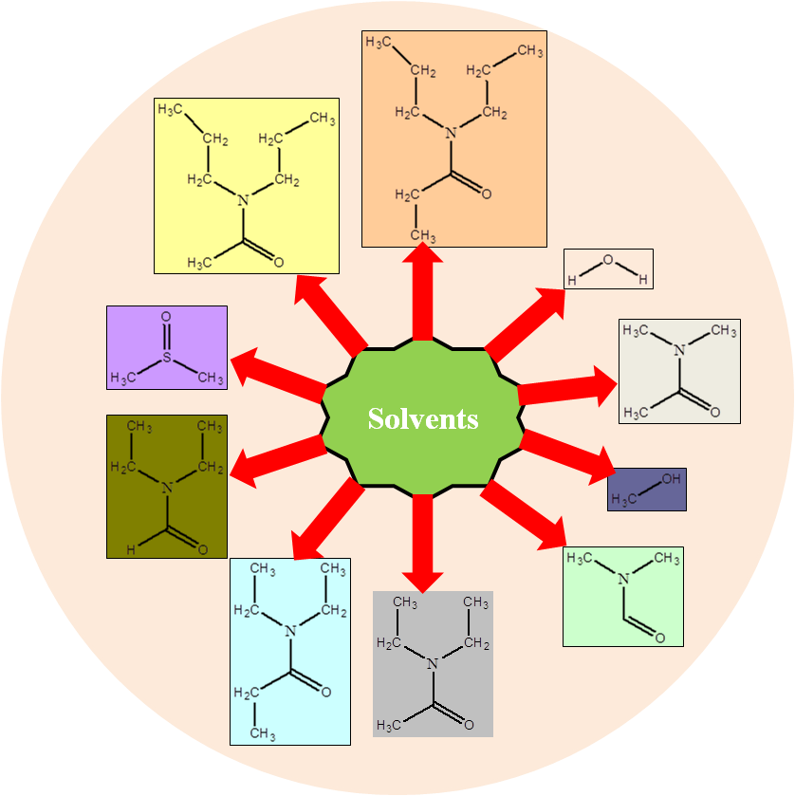

**Figure 4.** Solvents used in Synthesis of MOFs

MOF synthesis process is affected by the reaction medium because of polarity of solvent used and solubility and protolysis property of organic linker. It is also reported that different solvent systems in same reaction condition provide MOF of different morphology. This may happen because of difference in degree of deprotonation of organic linker in different solvent system. Banerjee et al[81] reported MOFs containing magnesium and PDC (3,5- pyridine dicarboxylic acid) having different crystal structure prepared under same condition using different solvent system(Figure 5 ). They found that coordination ability of solvent with metal determines the dimensionality of MOF network. Among DMF, H2O, EtOH and MeOH, H2O has the highest affinity towards Mg while EtOH and MeOH are not having any affinity to coordinate with metal centres when DMF/MeOH and EtOH/H2O are used as solvent.



**Figure 5.** Effect of solvent systems on morphology of MOF

In addition to structure, different solvent systems result in synthesis of MOFs having difference in pore size. MOFs of cobalt and 4,4’-((5-carboxy-1,3-phenylene bis(oxy)) dibenzoic acid (H3CPBDA) were synthesized using three different solvents viz. DMP, DMA and DMF under the similar conditions resulting into pore sizes of 76.84Å, 74.37Å and 72.76Å respectively. The change in pore size due to different solvents has beencorrelated with the size of the solvent molecule. Among the three solvents used the size of the molecules varies as DMP > DMA > DMF. The pore size also reduces in the same order[82]. Similar correlations are reported by other researchers[83].

**5. Effect oftemperature and pH on synthesis of MOFs**

Temperature and pH of reaction medium have remarkable influence on synthesis of MOFs. Different coordination modes can be adopted by linkersat different pH ranges[84]. Further, thedegree of deprotonation of linker increases on increasing the pH value. For example, Al3+ ion is coordinated with four, six and eight carboxyl O-atoms with increasing pHresultinginto MIL-121 (pH = 1.4), MIL-118 (pH = 2) and MIL-120 (pH = 12.2) respectively[85].Interpenetrated network has been reported to be formed at higher pH value and uninterpenetrated at lower pH[86]. Colour of MOF compounds also depend on pH of reaction medium. Luo et al[87], through their experimental work, explored three Co-MOF complexes, viz. [Co2(L)(HBTC)2(μ2-H2O)(H2O)2].3H2O **(1)**, [Co3(L)2(BTC)2].4H2O **(2)**, [Co2(L)(BTC)(μ2-OH)(H2O)2].2H2O **(3)**(L = 3,3’,5,5’- tetra(1H-imidazol-1-yl)1,1’-biphenyl and BTC = 1,3,5- benzenetricarboxylate)exhibit different structure and colour, by altering the pH value. Along with structure and colour, these three MOFs exhibited different adsorption capability. It is also revealed that compounds of higher dimension are formed at higher pH[88]. The effect of pH on various properties of MOFs is summarized in table 1 as reported in ref 88.

|  |  |  |  |  |
| --- | --- | --- | --- | --- |
| **S. No.** | **Properties of Co-MOFs** | **Complex-1** | **Complex-2** | **Complex-3** |
| **1** | Chemical Formula | [Co2(L)(HBTC)2(μ2-H2O)(H2O)2].3H2O | [Co3(L)2(BTC)2].4H2O | [Co2(L)(BTC)(μ2-OH)(H2O)2].2H2O |
| **2** | Morphology | Monoclinic | Monoclinic | Orthorhombic |
| **3** | Space group | P2/c | C2/c | Pccn |
| **4** | pH | 5 | 7 | 9 |
| **5** | Colour | Pink | Purple | Brown |

**Table 1.** Effect of pH on MOF

Temperature of the reaction is another important factor which affects the properties of synthesized MOFs. High temperature favours higher crystallization due to high solubility of reactants and results in formation of large crystals of high quality[89-91]. Nucleation and crystal growth rates were affected by temperature of reaction mixture.Morphology of synthesized MOFs can also be altered by varying the temperature of reaction medium. MOFs of Tm-succinate[92],are synthesized at different temperatures having same empirical formula but different morphology i.e. monoclinic and triclinic. Bernini et al. prepared two Ho-succinate MOFs and reported that the MOFs prepared via hydrothermal method at higher temperature is thermally more stable as compared to the other prepared at room temperature [93]. Along with thermal stability, hydrothermal methods also provide denser, less hydrated and higher dimensional solids[94].

**6. Factors affecting stability of MOFs**

**6.1 Surface engineering**

Crystal growth of MOFs can be alteredvia “Coordination Modulation”[95] which involves introduction of monodentate ligands known as “Modulators” having same functional group as to the existing multidentate organic ligand. Modulators can increase or decrease the crystal growth by controlling the nucleation leading to the formation of MOFs crystals of different size. When modulators decrease the crystal growth they can be used as “Capping agents”. Sodium acetate[96-99], sodium formate[99-101], acetic acid[102-104], benzoic acid[103], n-dodecanoicacid[105], trifluoroacetic acid (TFA)[106], pyridine[104], n-butyl amine[101], 1-methyl imidazole[101], polymers such as PVP[107], PEG[108], chitosan[108] have been used as modulators/capping agents in synthesis of MOF. It is also reported that the concentration of modulator can influence the crystal size and morphology of MOF crystals. In microwave synthesis[109] of HKUST -1, when lauric acid is used as modulator, the crystal sizes changes from nano to micro scale range. However, when capping agent is used in large amount formation of a new phase is induced[99]. Stability and specific properties of MOF crystals such as molecule sensing[107,110], drug delivery[108] etc. can be enhanced by using modulators. MOF111 coated with liposomes lipid has been explored for imaging and anticancer property. Effect of some modulators or capping agents on the properties of MOFs has been summarised in the Table-2

|  |  |  |  |  |
| --- | --- | --- | --- | --- |
| **S. No.** | **Modulator/caping agent** | **MOF** | **Change in MOF’s property** | **Ref** |
| 1 | Sodium formate | HKUST-1 | Reduction in crystal size, phase change | 100 |
| 2 | Sodium Acetate | MIL-68(In) | Decrease in length and diameter of hexagonal nanorods | 97 |
| 3 | n-dodecanoic acid | HKUST-1 | Change in morphology | 105 |
| 4 | Acetic acid | NH2-MIL-53 (Al) | Selective capping of crystal faces | 102 |
| 5 | Benzoic acid, acetic acid | UiO-66, UiO-66(NH2), UiO-67, UiO-68 | Improve crystallinity, formation of single crystal | 103 |
| 6 | TFA | UiO-66 | Induce defects | 106 |
| 7 | Sodium Acetate | [Ln(1,3,5-btc)(H2O)]n (Ln = Dy3+, Tb3+) | 2D nano sheet | 98 |
| 8 | PVP/silica | [Mn(1,4-bdc)(H2O)]n | Selective uptake in human cancer cell, Enhance imaging | 110 |
| 9 | PEG | MIL-88, MIL-100 | Improve aggregation, neutral zeta potential | 108 |

**Table 2.** Effect of capping agents/modulators on MOF properties

MOFs are also modified via exchanging a terminal ligand by a bridging ligand of different functionality. Research group of Kitagava successfully exchanged the surface ligands of Zn-based MOFs [Zn2(1,4-ndc)2(dabco)]n and [Zn2(1,4-bdc)2(dabco)]nwith a fluorescent dye boron dipyromethene (BODIPY). In these MOFs, only surface carboxylate ligands were exchanged and surface dabco ligands remained unmodified. Further, due to bulkier nature of BODIPY in comparison to original carboxylate ligand, it gets attached to surface only112. Liuet aldemonstrated[113] the effect of surface modification on properties of ZIF–8. It shows greater stability towards hydrolysis when its surface ligand 2-methylimidazole has been exchanged with more hydrophobic ligand 5,6-dimethylbenzimidazol (DMBIM).

Unlike linker ligand exchange, it has been difficult to control metal cation exchange in MOFs, as it can lead to the formation of Core-shell structure[114]. Kitagawa and group reported the core shell hybrid of Cu-MOF [Cu2(1,4-ndc)2(dabco)]nsynthesized on Zn analogous [Zn2(1,4-ndc)2(dabco)]nby adding Zn crystals to the solution of CuSO4.5H2O, 1,4-ndc and dabco. Formation of green crystals confirms the formation of Cu-MOF on Zn framework surface[115].



**Figure 6.**Effect of pH control and crystal capping during coordination modulation

**7. Major applications of MOFs**

In MOFs there is a simultaneous appearance of three characteristics viz. crystallinity, porosity and existence of strong metal-ligand interaction. The unique combination of these properties makes MOFs a very special class of materials[116]. MOFs show application in catalysis, drug delivery, gas storage, nanoparticle precursor, luminescence, electrochemistry and as sensor in technology.

**7.1 Gas storage and separation**

There are several methods for storing gas effectively but these require high pressure tank and multistage compressor. These methods are highly expensive for practical uses and there is a need of simpler and cheaper solution. To overcome these issues and to find safer storage methods, several materials, like Zeolite or activated porous carbons, have been studied for gas storage. In this context, MOFs have provided edge over other materials. This is due toeasy preparative methods, high surfacearea, wide opportunities for functionalization and tuneable pore structure which makes MOFs preferable compared to other porous materials.

More than 300 MOFs have been tested for H2 storage. One of the promising MOFs for this purpose is MOF-177 which consists of [Zn4O] clusters and 4,4’,4’’-benzene- 1,3,5 – triyltribenzoate (BTB) to form (6,3) net[117]. Due to its high surface area (~5000 m2g-1) and large pore volume it shows a gravimetric H2 uptake of 7.5 wt% at 70 bar and 77 K. MOF-5 (IRMOF-1), which is constructed from [Zn(OAc)2] and terepthalic acid, possesses a BET surface area of 3800 m2g-1 and takes up 7.1 wt% at 40 bar and 77 K. Apart from these two, MOF-210, MIL-101, HKUST-1, NU-100, PCN-12, NOTT-102 and MOF-205 are also known for H2 storage[118-121]. Generally MOFs with open metal sites provide high surface area facilitating stronger interaction between the metal ion and H2 molecule. This is the principal reason behind the high H2 uptake in MOFs. NU-100[120] has the highest excess H2 storage capacity i.e. 99.5 mgg-1 at 56 bar and 77 K. MOF-210[121] has been reported as highest total H2 storage capacity of value 176 mgg-1 at 80 bar and 77 K. In addition experimentally, it is reported that doping MOFs with metal ions could enhance the H2 uptake capacity[46,122].As compared to other H2 storage systems such as transition metal hydrides, MOFs require little energy to release adsorbed hydrogen. This released hydrogen can be used in automobile and fuel cell industries[123].

MOFs are reported to be useful for reducing CO2 level in atmosphere. For example, MOF-210 is thehighest surface area (10450 m2 g-1) MOF known to date,synthesized from 4,4’,4’’-[benzene-1,3,5-triyl-tris(ethyne-2,1-diyl)] tribenzoate (H3BTE), biphenyl- 4,4’- dicarboxylat (H2BPDC), and zinc(II)nitrate hexahydrate[121] and has an uptake of CO22400 mg g-1 (74.2 wt%, 50 bar at 298 K) whichexceeds that of any other porous material. MOF-200 has a similar CO2 uptakeas MOF-210 under similar experimental conditions[121]. Other well known MOFs, such as NU-100 (69.8 wt%, 40 bar at 298 K), Mg-MOF-74 (68.9 wt%, 36 bar at 278 K), MOF-5 (58 wt%, 10 bar at 273 K), and HKUST-1 (19.8 wt%, 1 bar at 298 K) also show considerable CO2 uptake. It has also been proved experimentally and theoretically that the presence of polar groups such as —NH2 or free N containing organic heterocyclic residues on the pores is helpful for high CO2 uptake compared with unfunctionalized analogues. One of the best examples, BioMOF-11, exhibited the effects of an N-heterocycle and its CO2 uptake of 15.2 wt% (at 1 bar and 298 K) exceeds any other MOF in the same category[124].

Noro et al. studied the first methane sorption study on MOFs[125]. Zhou and co-workers showed methane uptake of 16 wt% (35 bar) in PCN-14 [Cu2(adip), Adip = 5,5’-(9,10-anthracenediyl)di-isophthalate] MOF, having BET surface area 1753 m2 g-1[126]. Other MOFs such as HKUST-1 (15.7 wt% at 150 bar), MIL-101 (14.2 wt% at 125 bar), IRMOF-1 [228 cm3 (STP) g-1 at 298 K and ~36 bar], MOF-210 (264 mg g-1)[121] also show considerably high methane uptake capacity. In the case of Ni-MOF-74 [190 cm3 (STP) g-1 (298 K, 35 bar)], open metal sites are the dominating factor responsible for the high methane capacity[15]. Other important hydrocarbons like benzene, toluene, xylene and linear hydrocarbons have also been effectively separated from liquid mixtures by trapping inside MOFs.

Hazardous gases like CO and NO can also be separated from gas mixtures by using MOFs. Though separation of CO in MOFs could not be achieved experimentally, it is believed that interaction between CO dipole and open metal sites in MOFs are the dominating factor for the sorption performance. On the other hand, MOFs have been used for capturing NO gas, e. g. Cu-SIP-3[127] and Zn(TCNQ-TCNQ)(bpy) [TCNQ = 7,7,8,8-tetracyano-p-quino dimethane, bpy = 4,4’-bipyridyl][128]. Usually these two MOFs are nonporous in nature and they do not absorb gases like Ar, N2, CO2 etc., however, these are reported for uptake of NO gas (~9 molecules per formula unit at 1 bar) above gate – opening pressure. Reducing the pressure, the desorption path is not like adsorption. In 2010, Allen and co-workers reported the reason for this performance of the above two MOFs. The strong coordination to coordinatively unsaturated metal sites (CUMs) in case of Cu-SIP-3, while for [Zn(TCNQ-TCNQ)(bpy)], charge transfer plays a crucial role for high NO capture[127]. Ni- and Co-MOF-74 also exhibited very high NO uptake (~7.0 mmol NO per g of activated material) at room tempreture[129].

In 2014, D. Yan et al synthesized and characterized a new organic linker 1,2,4,5-tetrakis(3-carboxyphenyl)-benzene (m-H4TCPB) and its first metal-organic framework Cu-m-TCPB. This compound can uptake 24.4 cm3g-1 H2 and 2.3 cm3g-1 N2 at 77K and 1 atm. It has been reported to possess uptake capacity 23.3 cm3g-1 acetylene, 23.0 cm3g-1 CO2 and 7.3 cm3g-1 at 273K and 1 atm[130].

Instead of gaseous molecule uptake, some MOFs have also been prepared which are capable of adsorption of water molecule. In this direction, R. Banerjee and his research group demonstrated the water adsorption ability of chemically stable keto-enamineCOFs[131].

**7.2 Magnetism and its application**

Metal organic framework materials show magnetism when paramagnetic 3d transition metal nodes are used along with suitable diamagnetic organic linkers and MOFs having magnetic properties are named as magnetic metal organic frameworks (MMOFs). The MOFs consist of first-row transition metals (V, Cr, Mn, Fe, Co, Ni and Cu) have contributed significantly to develop porous molecular magnets[132-137]. Close-shell ligands[138] such as oxo, cyano, azido bridges and polycarboxylic ligands, which give weak magnetic interaction, are good candidates for this purpose.

Another reason for magnetic behaviour of MOFs is the framework structure, which may involve layered geometry with a shorter conjugated distance between metal clusters. Organic linkers have also been used for synthesis of MMOFs, where radicals present in organic linker are responsible for magnetic properties. This metal-radical combined approach has also been used for synthesizing a variety of MMOFs[139-141].

A Ni-Glutarate based MOF[142] [Ni20(H2O)8(C5H6O4)20.40H2O] showed ferromagnetic behaviour with a curie temperature of 4K due to weak ferromagnetic interactions of Ni-O-Ni angle. HKUST-1 is antiferromagnetic at high temperature and below 65K shows weak ferromagnetism[143]. MIL-9[144] [Co5(OH)2(C4H4O4)4] is reported to possessferrimagneticproperties. Jain[145] et al reported four MOFs of general formula [(CH3)2NH2]M(HCOO)3 (M = Mn, Fe, Co, Ni) as multiferroics.

Instead of 3d transition metals, lanthanides also produce magnetic metal-organic frameworks. Two magnetic lanthanide-organic frameworks[146] (LnOF), having formula [Dy2(bpa)2(H2O)3] and [Er4(bpa)4(H2O)6](H2O), consist a 3D frameworks built by the 1D rod shaped metal carboxylate SBUs and 3,5-bis(4-carboxyphenoxy)benzoate (bpa3-) ligands.

Magnetic MOFs can also be explored for the environmental application in removal of arsenic. Magnetic nanoclusters have been reported for applications in arsenicremoval[147,148].

**7.3 Sensing**

A large number of MOFs have been reported to be photoluminescent because aromatic units of linkers in most of the MOFs lead to excitation by absorbing UV-visible light and provide luminescence. MOFs as luminescent materials or phosphors can find application in cathode ray tubes, projection television, fluorescent tubes and X-ray detectors[149], small-molecule sensors[150,151], pH sensors[152], light concentrators for photovoltaic devices, antennae in photo-sensitive bioinorganic compounds and high-technology optics. Trivalent lanthanide metal ions are widely used for synthesis of luminescent MOFs due to their electronic transition from d- to f- shell, with accompanying photon emission. Lanthanides like Eu, Tb, Dy, Sm, Nd, Gd, Er and Yb are used as luminescent metal ions. Naphthalene, anthracene, pyrene, perylene and stilbene types of ligands are most commonly used for synthesis of luminescent MOFs. Both the metal and the linker can be used to give rise to luminescence, and can furthermore interact (via antenna effect) to increase the brightness and the quantum yield. 4,4-[(2,5-Dimethoxy-1,4-phenylene)-di-2,1-ethenediyl]bisbenzoic acid (H2pvdc) was used to efficiently sensitise the NIR emission of the Yb3+ ions at ca. 1000 nm in an extended [Yb2(pvdc)3(H2O)2].6DMF.8.5H2O porous network[153]. The LnMOFs co-doped with multiple Ln3+ ions can be used as bimodal (or multicoloured) light emitters. Bimodal (or multicoloured) emission may be applied in multiplexed detection and imaging of therapeutic cells[154]. Ln-MOFs are used in cation sensing, anion sensing as well as molecule sensing. A visible colour change of material is one of the simplest, most powerful sensing strategies. For example, a nanotubular MOF, {[(WS4Cu4)I2(dptz)3].DMF}n (dptz = 3,6-di-(pyridin- 4-yl)-1,2,4,5-tetrazine, DMF = N,N-dimethylformamide) was reported for sensing small solvent molecules. When accommodating different solvent molecules as guests, the resulting inclusion compounds exhibited different colours depending on the solvent guests, showing a new way of signal transduction as a new kind of sensor[150]. Recently, water stable cationic MOF[155] has been reported which can adsorb oxoanionicpollutents such as MnO4-, Cr2O72-. Recently, MOFs have been demonstrated as chemical sensor for selective fluorescence quenching of a explosive TNP (2,4,6-tri nitro phenol) in water using urotropin-based metal-organic framework[156] (Ur-MOF).

Nano MOFs (NMOFs) have been another exciting developmentand NMOFs are used for sensing pesticides. Akash deep et al[157] were the first who demosnstratedbiosensing application of Nano MOF [Cd(atc)(H2O)2]n (atc = 2-amino terepthalic acid) impedimetrically for the detection of organo-phospatepestiside by developing a anti-paration/NMOF/2-ABA/ITO (ABA = 2-amino benzyl amine, ITO = Indium Tin oxide) sensing platform.

A novel approach to develop an inkless and erasable printing medium using MOFs has been demonstrated by synthesizing photochromic MOF[158] containing 1,4,5,8-naphthalenediimide (NDI) and Ca, Mg, Sr and revealed their inkless printing property. The print content was self erasedafter 24 hours. This may be useful for reducing paper wastage.

**7.4 Catalysis**

The presence of strong metal – ligand interaction in MOFs can provide permanent porosity to the material i.e. it is possible to remove solvent molecules completely without structure collapse.MOFs have shown great potential as heterogeneous catalyst. The MOFs, in which metal centres are not completely blocked by organic ligands or unsaturated, i.e. labile ligands are introduced, are good catalysts because when labile ligands are generally solvent molecules and when they are removed leave a free coordination position on the metal. For example, [Cu3(btc)2] (btc = 1,3,5-benzenetricarboxylate) material HKUST-1, in which coordinated water molecule leaves a coordination vacancy on Cu upon thermal activation[159]. A number of organic reactions have been catalysed by using nanoporous MOFs. For example,Knoevenagel condensation reaction catalysed by using either [Cd(4-btapa)2(NO3)2][160](btapa = 1,3,5-benzene tricarboxylic acid tris[N-(4-pyridyl)amide]) or [Cr3F(H2O)2O(bdc)3][161] (bdc = 1,4-benzenedicarboxylate). Jing Xu et al synthesised a novel bimetal complex [Zn4Ru2(bpdc)4.4C2NH8.9DMF]n (H2bpdc = 4,4’-biphenyldicarboxylic acid), which can adsorb Ru(II) photosensitizer [Ru(bpy)3]2+ and cobalamin derivative such as heptmethylcobyrinate perchlorate (B12) to form a complex B12-Ru@MOF. This complex has been reported to catalysedechlorination reaction and 1,2-migration reaction in solid state. This is the first example of B12 catalysis using MOF system[162].

**7.5 Biomedical application**

MOFs offer extremely high drug loading capacity and very long release time. As compared to mesoporous silica materials MOFs can load four times greater drug i.e. ibuprofen adsorption (upto 1.4 gm per gram of MOFs) with longer release time (upto 21 days)[108].Non-toxic MOFs are applicable in targeted drug delivery. MIL family of metal-organic frameworks has a good candidature for storage and controlled release of biologically important molecules due to their enhanced stability, enormous porosity and large pore volume[10,163].Serrey and Férey et al[8] demonstrated encapsulating drug molecules (Ibuprofen) in chromium carboxylate MOFs, MIL – 100 and MIL -101, exhibiting drug storage capacities of 35 wt% and 140 wt% respectively and controlled drug release behaviour of 5 to 6 days under physiological conditions.Iron(III) carboxylate MOFs such as MIL-88A, MIL-8, MIL-100 and MIL-101 are able to entrap anticancer[163], antitumor and antiretroviral drugs as well as cosmetic agents[8]. Férey et al[164] reported first group of synthesized MOFs using trivalent metal centers with carboxylic acid bridging for drug delivery application. A novel type of magnetic MOF composite Fe3O4/Cu3(BTC)2, fabricated by incorporation of Fe3O4nanorods with nanocrystals of Cu3(BTC)2 (HKUST-1), adsorbedupto 0.2 gm of Nimesulide (an anticancer drug for pancreatic cancer treatment) per gram of composite and it took as long as 11 days for the complete drug release in physiological saline at 37˚C[165].Zhuang et al demonstrated ZIF-8 as pH responsive drug delivery system with high cellular uptake efficiency by incorporatingcamptothecin into ZIF-8 nanospheres. This encapsulated ZIF-8 exhibited enhanced cell death[11].

Bernini et al demonstrated the ability of GCMC (Grand canonical montecarlo) simulation to predict the microscopic performance of new porous MOFs in drug delivery application and validated their simulation, with the available experimental data reported for the adsorption-release of ibuprofen in MIL-53(Fe), MIL-100(Fe) and MIL-101(Cr)[166]. Their simulation predicted an outstanding ibuprofen adsorption capacity of 1969 mg g-1 for mesoporous BioMOF-100 which is six times higher than the values reported for mesoporous silica. The presence of strong electrostatic interactions due to existence of charge compensating ions in MOFs enhances the adsorbate-adsorbent interaction which leads to higher drug loading at low pressure. In BioMOF-100, dimethylammoniumcations present in the pores reinforce the attractive interaction with ibuprofen molecules. Monte carlo simulation was also used for comparing the drug uptake capacity of two different mesoporous MOFs viz. MIL-101 and UMCM-1 computationally[9].

Anti bacterial activity of novel MOF STAM-1[138] has been compared with that of the HKUST-1 against the growth of some bacteria such as *Clostridium difficle, Staphylococcus aureus*and *Pseudomonas aeruginosa.* It is found that both the MOFs have significant effect against the growth of these pathogens. Antimicrobial activity of these MOFs has been enhanced when they are impregnated with NO.

**7.6 Electrical property and its application**

MOFs have been demonstrated as useful device material for energy storage. Electrical storage capacity of MOFs in Co-doped MOF-5 i.e. Co8-MOF-5[167] as electrode for supercapacitors has been reported by Diaz et al. However, this MOF has much lower capacitance than the commercially activated carbon. Lee et al introduced Cobalt based MOF film[168] which has pseudocapacitor behavior with specific capacitance upto 206.76 F g-1 and energy density of 7.18 Wh kg-1at 0.6 A g-1. Zn-doped Ni-based MOF[169] with a flowerlike microsphere exhibited high specific capacitance (1620 F g-1 and 860 F g-1 at 0.25 and 10 A g-1 respectively), good rate capability and good cycling stability (91% for the MOF with Zn/Ni of 0.26). In 2014, a series of 23 different nanocrystalline MOFs (nMOFs) were reported for their electrochemical energy storage capacity. Among these nMOFs a zirconium based MOF i.e. nMOF-867 exhibited high capacitance. nMOF-867 has the stack and areal capacitance of 0.64 and 5.09 mF cm-2 which is are about six times higher than that of the supercapacitors made from activated carbon[170]. Recently, a Mn-based MOF is employed as the active coating material to enhance the capacity of Li-rich layered Li(Li0.17Ni0.20Co0.05Mn0.58)O2 oxide as cathode for Li-ion batteries. This surface modified oxide material showed a large discharge capacity, good thermal stability without harming the cycle stability, high initial coulombic efficiency and high rate capability[171].Researches in this direction are needed to further explore the applications of MOFs.

**8. Future Scope**

The knowledge about metal organic frameworks is growing rapidly during recent few years but there are still significant gaps in the completeness of our understanding of theirstructure, stability and properties.Detailed investigations on factors responsible for destruction of crystal structure of certain MOFs with timestability and decomposition mechanism have still not been carried out systematically.

There are some reports on applications of MOFs in drug loading and delivery for some anticancer and antiviral molecules. MOFs can be explored for such application for other drug molecules too. Detailed toxicological investigation should be carried out commercialization of such products.

**9. Conclusion**

In this review article, we have discussed various synthetic methods of MOFs along with their applications. Different methods lead to the MOFs having different properties. MOFs introduced a huge number of applications including gas storage and separation, catalysis, magnetism, sensors, electrical energy storage systems etc. Several applications of MOFs have not been explored yet, for instance, magnetic MOFs can be explored for removal of arsenic from environmental sample same as magnetic nano clusters have been demonstrated. Research work should be carried out to study degradation mechanism of unstable MOF. Studies can also be carried out to evaluate the toxicity of degradation products. These studies will be helpful to explore the biomedical application of nontoxic MOFs. Nontoxic MOFs can be explored for application as solid support for natural bioactive molecules to increase their shelf life and effectiveness.

MOFs should be evaluated for antibacterial and antifungal activities to explore their clinical and biological applications as solid support, UV-screens and synergist.

**Abbreviations used**

1. Adip – 5,5’-(9,10-anthracenediyl)di-isophthalate
2. BDC – benzene dicarboxylate
3. BODIPY - boron dipyromethene
4. BTC – benzene tricarboxylate
5. COF – covalent organic framework
6. DABCO – di aza bicycle octane
7. HKUST – hongkong university of science and technology
8. IRMOF – isoreticular metal organic framework
9. MIL – Materials of institute Lavoisier
10. MOF – metal organic framework
11. MW - microwave
12. NDC – naphthalene dicarboxylate
13. NU – North western university
14. PCN – porous coordination network
15. PCP – porous coordination polymer
16. SBU – Secondary building Unit
17. SIP – 5-sulfoisophthalic acid
18. SNU – Seoul National University
19. STAM – st.andrews material
20. TCPB – tetra kis(carboxyphenyl)benzene
21. TFA – trifluoro acetic acid
22. ZIF – zeoliticimidazolate framework

**References**

1. Eddaoudi M, Moler DB,Li H, *et al*. Modular Chemistry: Secondary building units as basis for the design of highly porous and robust metal-organic carboxylate framework. Accountsof Chemical Research 2001; 34: 319-330.

2. Rowsell JLC, Yaghi OM. Metal-organic frameworks: a new class of porous materials.Microporous and MesoporousMater 2004; 73: 3-14.

3. Yamada T, Kitagawa H. Protection and deprotection approach for the introduction of functional groups into metal organic frameworks. Journal of the American Chemical Society 2009; 131: 6312-6313.

4. Horike S, Shimomura S,Kitagawa S. Soft porous crystals.Nature Chemistry2009; (9):695-704, Doi: 10.1038/nchem.444.

5. Ferey G. Hybrid porous solids: Past, present, future.Chemical Society Reviews 2008; 37:191-214.

6. Lee J, Farha OK, Roberts J, *et al*. Metal-organic framework material as catalyst. Chemical Society Reviews 2009; 38: 1450-1459.

7. Horcajada P, Serre C, Maurin G, *et al*. Flexible porous metal-organic frameworks for a controlled drug delivery. Journal of the American Chemical Society 2008; 130:6774-6780.

8. Horcajada P, Serre C, Vallet-regi M, *et al*. Metal-organic frameworks as efficient materials for drug delivery. AngewandteChemie International Edition 2006; 45:5974-5978.

9. Babarao R, Jiang J. Unraveling the energatics and dynamics of Ibuprofen in mesoporous metal-organic frameworks. The Journal of Physical Chemistry 2009; 113:18287-18291.

10. Horcajada P, Gref R, Baati T, *et al*. Metal-organic frameworks in Biomedicine. ChemicalReviews 2012; 112: 1232-1268.

11. Zhuang J, Kuo CH, Chou LY, *et al*. Optimized metal-organic frameworks nanospheres for drug delivery: evaluation of small-molecule incapsulation. ACSnano 2014; 8(3):2812-2819.

12. Kerbellec N, Catala L, Daiquebonne C, *et al*. Luminescent coordination nanoparticles. New Journal of Chemistry 2008; 32: 584-587.

13. Kitagawa S, Matsuda R. Chemistry of coordination space of porous coordination polymers. Coordination Chemistry Reviews 2007; 251: 2490-2509.

14. Kitagawa S, Kitaura R, Noro SI. Functional porous coordination polymers. Angewandte Chemie International Edition 2004; 43: 2334-2375.

15. Wu H, Zhou W, Yildirim T. High-capacity methane storage in metal-organic frameworks M2(dhtp): the important role of open metal site. Journal of the American Chemical Society 2009; 131: 4995-5000.

16. Zacher D, Shekhah O, Woll W, *et al*. Thin films of metal-organic fameworks. Chemical Society Reviews 2009; 38: 1418-1429.

17. Ma M. Preparation, characterization of metal-organic frameworks for biological applications. Ph.D. thesis, Ruhr Universitty, Bochum. 2011, 11.

18. Maark TA, Pal S. A model study of effect of M = Li, Na, Be, Mg and Al ion decoration on hydrogen adsorption of metal-organic framework-5. International Journal of Hydrogen Energy 2010; 35:12846-12857.

19. Lv YK, Zhan CH, Feng YL. A Chiral manganese-potassium heterometallic MOF with an unusual (3,7)-connected network CrysEngComm 2010; 12:3052-3056.

20. Yang LM, Vajeeston P, Ravindran P, *et al*. Revisiting isoreticular MOFs of alkaline earth metals: A comprehensive study on phase stability, electronic structure, chemical bonding and optical properties of A-IRMOF-1 (A = Be, Mg, Ca, Sr, Ba). Physical Chemistry Chemical Physics 2011; 13: 10191-10203.

21. Platero-Prats AE, Iglesias M, Snejko N, *et al*. From coordinatively weak ability of constituents to very stable alkaline earth sulphonate metal-organic framework. Crystal Growth & Design 2011; 11(5): 1750-1758.

22. PlateroPrats AE, de la Peña-O'Shea VA, Iglesias M, *et al*. Heterogeneous catalysis with alkaline-earth metal-based MOFs: A Green calcium catalyst. Chem Cat Chem 2010; 2: 147-149.

23. Serre C, Ferey G. Hydrothermal synthesis, thermal behaviour and structural determination from powder data of a porous three dimensional europium trimesate: Eu3(H2O)(OH)6[C6H3(CO2)3].3H2O or MIL-63. Journal of Materials Chemistry 2002; 12: 3053-3057.

24. Serre C, Millange F, Marrot J, *et al*. Hydrothermal synthesis, structural determination and thermal behaviourofthree dimensional europium terephthalates: MIL-51LT,HT and MIL-53 or Eu2n(OH)x(H2O)y[O2C-C6H4-CO2]z (n – III, III, II; x = 4, 0, 0; y = 2, 0, 0; z = 1, 1, 2). Journal of Materials Chemistry 2002; 14: 2409-2415.

25. Reineke TM, Eddaoudi M, O'Keeffe M, *et al*. A microporous lanthanide-organic framework. Angewandte Chemie International Edition 1999; 38:2590-2594.

26. Serpaggi F, Ferey G. Hybride open frameworks (MIL-n) part 4 synthesis, and crystal structure of MIL-8 a series of lanthanide glutarates with an open framework, [Ln(H2O)]2[O2C(CH2)3CO2]3.4H2O. Journal of Materials Chemistry 1998; 8:2737-2741.

27. Serpaggi F, Ferey G. Hybrid open frameworks (MIL-n): synthesis and crystal structure of MIL-17 a rare-earth dicarboxylate with a relatively open framework [Pr(H2O)]2[O2C(CH2)2CO2]3.H2O. MicroporousMesoporous Mater 1999; 32: 311-318.

28. Yaghi OM, O’keeffee M, Ockwing NW, *et al*. Reticular synthesis and design of new materials Nature 2003; 423: 705-714.

29. Sabouni R. Carbon dioxide adsorption by metal organic frameworks (Synthesis, testing and modeling) Ph.D. thesis, University of western Ontario, Electronic thesis and dissertation repository 2013, 28-29.

30. Dincă M, Long JR. Strong H2 binding and selective gas adsorption within the microporous coordination solid Mg3(O2C-C10H6-CO2)3. Journal of the American Chemical Society 2005; 127:9376-9377.

31. Hamon L, Llewellyn PL, Devic T, *et al*. Co-adsorption and separation of CO2-CH4 mixtures in the highly flexible MIL-53(Cr) MOF. Journal of the American Chemical Society 2009; 131:17490-17499.

32. Llewellyn P, Bourrelly S, Serre C, *et al*. How hydration drastically improves adsorption selectivity for CO2 over CH4 in the flexible chromium terephthalate MIL-53. AngewandteChemie International Edition 2006; 45:7751-7754.

33. Serre C, Mellot C, Surblé S, *et al*. Role of solvent-host interactions that lead to very large swelling of hybrid frameworks. Science 2007; 315:1828-1831.

34. Choi H, Suh M. Highly selective CO2 capture in flexible 3d coordination polymer networks. Angewandte Chemie International Edition 2009; 48:6865-6869.

35. Schneemann A, Bon V, Schwedler T, *et al*. Flexible metal-organic frameworks. Chemical Society Reviews 2014; 43: 6062-6096.

36. Liang Z, Marshall M, Chaffee AL. CO2 adsorption-based separation by metal organic framework (Cu-BTC) versus zeolite (13X). Energy and Fuels 2009; 23:2785-2789.

37. Millward A, Yaghi OM. Metal-organic frameworks with exceptionally high capacity for storage of carbon dioxide at room temperature. Journal of the American Chemical Society 2005; 127:17998-17999.

38. Demessence A, D'Alessandro D, Foo M, *et al*. Strong CO2 binding in a waterstable, triazolate-bridged metal-organic framework functionalized with ethylenediamine. Journal of the American Chemical Society 2009; 131:8784-8786.

39. Serre C, Bourrelly S, Vimont A, *et al*. An explanation for the very large breathing effect of a metal-organic framework during CO2 adsorption. AdvancedMaterials 2007; 19:2246-2251.

40. Sumida K, Rogow DL, Mason JA, *et al*. Carbon Dioxide capture in Metal-organic frameworks. Chemical Reviews 2012; 112: 724-781.

41. Wang C, Ying JY. Sol-gel synthesis and hydrothermal processing of anatase and rutile titaniananocrystals. Chemistry of Materials 1999; 11:3113–3120. Doi: 10.1021/cm990180f.

42. Huang L, Wang H, Chen J, *et al*. Synthesis, morphology control and properties of porous metal-organic coordination polymers. Microporous Mesoporous Materials 2003; 58: 105-114.

43. Tranchemontagne DJ, Hunt JR, Yaghi OM. Room temperature synthesis of metal-organic frameworks: MOF-5, MOF-74, MOF-177, MOF-199 and IRMOF-0.2008; Tetrahedron 64: 8553-8557.

44. Cravillion J, Munzer S, Lohmeier SJ, *et al*. Rapid room temperature synthesis and characterization of nanocrystals of a prototypical zeoliticimidazolate framework. Chemistry of Materials 2009; 21(8): 1410-1412.

45. Biemmi E, Christan S, Stock N, *et al*. High through screening of synthesis parameters in the formation of metal-organic frameworks MOF-5 and HKUST-1. MicroporousMesoporous Materials 2009; 117:111-117.

46. Nouar F, Eckert J, Eubank JF, *et al*. Zeolite like metal-organic framework (ZMOFs) as hydrogen storage platform: Lithium and magnesium ion exchange and H2-(rho-ZMOF) interaction studies. Journal of the American Chemical Society 2009; 131(8): 2864-2870.

47. Braga D, Giaffreda SL, Grepioni F, *et al*. Solvent effect in a “solvent free” reaction. CrystEnggComm 2007; 9: 879-881.

48. Pichon A, James SL. An array based study of reactivity under solvent free mechanochemical conditions - insights and trends. CrystEnggComm 2008; 10: 1839-1847.

49. Stock N, Biswas S. Synthesis of metal-organic frameworks (MOFs): Routes to various MOFs topologies, morphologies and composites. Chemical Reviews 2012; 112: 933-969. Doi: 10.1021/cr200304e.

50. Pichon A, Lazuen-Garay A, James SL. Solvent free synthesis of a microporous metal-organic framework. CrystEngComm 2006; 8: 211-214.

51. Shinde DB, Aiyappa HB, Bhadra M, *et al.* A mechanochemically synthesized covalentorganic framework as a proton-conducting solidelectrolyte. Journal of Materials Chemistry 2016. ADOI: 10.1039/c5ta10521h.

52. FriscicT, Fabian L. Mechanochemical conversion of a metal oxide into coordination polymers and porous frameworks using liquid assisted grinding. CrystEngComm 2009; 11:743-745.

53. Jhung SH, Chang JS, Hwang JS, *et al*. Selective formation of SAPO-5 and SAPO-34 molecular sieves with microwave irradiation and hydrothermal heating. MicroporMesopor Materials 2003; 64:33-39. Doi: 1[0.1016/S1387-1811(03)00501-8](http://dx.doi.org/10.1016/S1387-1811(03)00501-8" \t "doilink).

54. Jhung SH, Lee JH, Yoon JW, *et al*. Selective crystallization of CoAPO-34 and VAPO-5 molecular sieves under microwave irradiation in an alkaline or neutral condition. MicroporMesopor Materials 2005; 80:147-152. Doi: [10.1016/j.micromeso.2004.11.013](http://dx.doi.org/10.1016/j.micromeso.2004.11.013" \t "doilink).

55. Kang KK, Park CH, Ahn WS. Microwave preparation of titanium-substituted mesoporous molecular sieve. Catalysis Letters 1999; 59(1): 45-49.

56. Jhung SH, Chang JS, Hwang YK, *et al*. Crystal morphology control of AFI type molecular sieves with microwave irradiation. Journal of Materials Chemistry 2004; 14: 280-285.

57. Hwang YK, Chang JS, Park SE, *et al*. Microwave fabrication of MFI zeolite crystals with a fibrous morphology and their applications. Angewandte Chemie International Edition 2005; 44: 556-560.

58. Jhung SH, Lee JH, Chang JS. Microwave synthesis of nanoporous hybrid material, Chromium trimesate. Bulletin of the Korean Chemical Society 2005; 26:880-881.

59. Lu CM, Liu J, Xiao K, *et al*. Microwave enhanced synthesis of MOF-5 and its CO2 capture ability at moderate temperatures across multiple capture and release cycles. Chemical Engineering Journal 2010; 156: 465-470.

60. Schlesinger M, Schulze S, Hiestchold M, *et al.* Evolution of synthetic methods for microporous metal-organic frameworks exemplified by the competitive formation of [Cu2(btc)3(H2O)3] and [Cu2(btc)(OH)(H2O)]. MicroporousMesoporous Materials 2010; 132: 121-127.

61. Mueller U, Puetter H, Hesse M. Wessel M Method for electrochemical production of a crystalline porous metal organic skeleton material. Patent - WO2005/049892.

62. Mueller U, Schubert M, Teich F, *et al*. Metal-organic frameworks – Prospective industrial applications. Journal of Materials Chemistry 2006; 16: 626-636.

63. Richer I, Schubert M, Müller U. Porous metal organic framework based on pyrroles and pyridinones. Patent WO2007/131955.

64. Suslick KS, Choe SB, Cichowlas AA, *et al*. Sonochemical synthesis of amorphous iron. Nature 1991; 353: 414-416.

65. Gedanken A. Sonochemical synthesis of amorphous iron. UltrasonSonochem 2004; 11: 47-55.

66. Sono T, Mingos DMP, Baghurst DR, *et al.* Novel energy source for reactions. In the new chemistry: Hall N Ed, The press Syndicate of the university of Cambridge. Cambridge, Chapter 4, 2004.

67. Qiu LG, Li ZQ, Xu T, *et al*. Fecile synthesis of nanocrystals of a microporous metal-organic framework by an ultrasonic method and slecting sensing of orgnoamines. ChemCommun 2008; 3642-3644.

68. Li ZQ, Qiu LG, Su T, *et al*. Ultrasonic synthesis of the microporous metal-organic framework Cu3(BTC)2 at ambient temperature and pressure: An efficient and environmentally friendly method. Materials Letters 2009; 63: 78-80.

69. Zacher D, Yusenko K, Bétard A, *et al*. Liquid – phase epitaxy of multicomponent layer based porous coordination polymer of thin films of [M(L)(P)0.5] type: importance of deposition sequence on the oriented growth. Chemistry: A European Journal 2011; 17: 1448-1455.

70. Mei BaiM, Zhang JB, Cao LH, *et al*. Zinc(II) and cadmium(II) metal complexes with bis(tetrazole) ligands: synthesis and crystal structure. Journal of the Chinese Chemical Society 2011; 58: 69-74.

71. Shekhah O. Layer by layer method for the synthesis and growth of surface mounted metal-organic frameworks (SURMOFs). Materials 2010; 3:1302-1315.

72. Shekhah O, Wang H, Zacher D, *et al*. Growth mechanism of metal-organic framework: insights into the nucleation by employing a step by step route. Angewandte Chemie International Edition 2009; 48: 5038-5041.

73. Horcajada P, Serre C, Grosso D, *et al*. Colloidal route for preparing optical thin films of nanoporous metal-organic frameworks. Advanced Materials 2009; 21: 1931-1935.

74. Demessence A, Horcajada P, Serre C, *et al*. Elaboration and properties of hierarchically structured optical thin films of MIL-101(Cr). ChemCommun 2009; 7149-7151.

75. Demessence A, Boissiѐre C, Grosso D, *et al*. Adsorption properties in high optical quality nanoZIF-8 thin folms with tunable thickness. Journal of Materials Chemistry 2010; 20: 7676-7681.

76. Cooper ER, Andrews CD, Wheatley PS, *et al*. Ionic liquids as eutectic mixtures as solvent and template in synthesis of zeolite analogues. Nature 2004; 430: 1012-1016.

77. Parnham ER, Morris RE. Ionothermal synthesis of zeolites, metal-organic frameworks and inorganic-organic hybrids. Accounts of Chemical Research 2007; 40: 1005-1013.

78. Aiyappa HB, Saha S, Garai B, *et al*. A Distinctive PdCl2-Mediated Transformation of Fe-BasedMetallogels into Metal−Organic Frameworks. Crystal Growth & Design 2014; 14: 3434−3437.

79. Yakovenko AA, Wei Z, Wriedt M, *et al*. Study of guest molecules in metal-organic frameworks by powder X-ray diffraction: Analysis of difference envelopedensity. Crystal Growth & Design 2014; 14(11): 5397–5407.

80. Akhbari K, Morsali A. Effect of the guest solvent molecules on preparation of different morphologies of ZnOnanomaterials from the [Zn2(1,4-bdc)2(dabco)] metal-organic framework. Journal of Coordination Chemistry 2011; 64(20): 3521–3530.

81. Banerjee D, Finkelstein J, Smirnov A, *et al*. Synthesis and structural characterization of magnesium based coordination networks in different solvents. Crystal Growth & Design 2011; 11: 2572-2579.

82. Huang WH, Yang GP, Chen J, *et al*. Solvent influence on sizes of channels in three new Co(II) complexes, exhibiting an active replaceable coordinated site. Crystal Growth & Design 2013; 13(1): 66-73.

83. He YC, Guo J, Zhang HM, *et al*. Tuning the void volume in a series of isomorphic porous metal-organic frameworks by varying the solvent size and length of organic ligands. CrystEngComm 2014; 16(24): 5450-5457.

84. Seetharaj R, Vandana PV, Arya P, *et al*. Dependence of solvents, pH, molar ratio and temperature in tuning metal organic frameworks. Arabian Journal of Chemistry 2016. doi: 10.1016/j.arabjc.2016.01.003.

85. Volkringer C, Loiseau T, Guillou N, *et al*. High thoughput aided synthesis of the porous metal-organic framework-type aluminium pyromillitate MIL-121 with extra carboxylic acid functionalization. Inorganic Chemistry 2010; 49: 9852-9862.

86. Yuan F, Xie J, Hu HM, *et al*. Effect of pH/metal ion on the structure of metal-organic frameworks based on novel bifunctionalized ligand 4’-carboxy-4,2’:6’, 4’’-terpyridine. CrystEngComm 2013; 15(7):1460–1467.

87. Luo L, Lv GC, Wang P, *et al*. pH-Dependent cobalt(ii) frameworks with mixed 3,3’,5,5’-tetra(1H-imidazol-1-yl)-1,1’-biphenyl and 1,3,5-benzenetricarboxylate ligands: synthesis, structure and sorption property. CrystEngComm 2013; 15(45): 9537–9543.

88. Chu Q, Liu GX, Okamura T, *et al*. Structure modulation of metal–organic frameworks via reaction pH: Self-assembly of a new carboxylate containing ligand N-(3-carboxyphenyl)iminodiacetic acid with cadmium(II) and cobalt(II) salts. Polyhedron 2008; 27(2): 812–820.

89. Wang CC, Jing HP, Wang P, *et al*. Series metal-organic frameworks constructed from 1,10-phenanthroline and 3,3’,4,4’-biphenyltetracarboxylic acid: Hydrothermal synthesis, luminescence and photocatalytic properties. Journal of Molecular Structure 2015; 1080: 44-51.

90. Zang CY, Wang MY, Li QT, *et al*. Hydrothermal synthesis, crystal structure and luminescent properties of two zin(II) and cadmium(II) 3D metal-organic frameworks. Zeitschriftfüranorganisch and allgemeineChemie 2013; 639(5): 826-831.

91. Yang LT, Qiu LG, Hu SM, *et al*. Rapid hydrothermal synthesis of MIL-101(Cr) metal–organic framework nanocrystals using expanded graphite as a structure-directing template. Inorganic Chemistry Communications 2013; 35: 265–267.

92. De Oliveira CAF, da Silva FF, Malvestiti I, *et al*. Effect of temperature on formation of two new lanthanide metal-organic frameworks: synthesis, characterization and theoretical studies of Tm(III)-succinate. Journal of Solid State Chemistry 2013; 197: 7–13.

93. Bernini MC, Brusau EV, Narda GE, *et al*. The effect of hydrothermal and non-hydrothermal synthesis on the formation of holmium(III) succinate hydrate frameworks. European Journal of Inorganic Chemistry 2007; 5: 684–693.

94. Zhang KL, Hou CT, Song JJ, *et al*. Temperature and auxiliary ligand-controlled supramolecular assembly in a series of Zn(ii)-organic frameworks: syntheses, structures and properties. CrystEngComm 2012; 14(2): 590–600.

95. Mcguire CV, Forgan RS. The surface chemistry of metal-organic frameworks. ChemCommun 2015; 51: 5199-5217.

96. Jin LN, Liu Q, Sun WY. Size-controlled indium(III)-benzendicarboxylate hexagonal rods and their transformation to In2O3hollow structure. Cryst EngComm 2013; 15: 4779–4784.

97. Goesten M, Stavitski E, Pidko EA, *et al*. The molecular pathway to ZIF-7 microrods revealed by in situ time resolved small- and wide- angle x-ray scattering, quick scanning X-ray absorption spectroscopy and DFT calculation. Chemistry: A European Journal 2013;19: 7809–7816.

98. Zhao J, GuoY, Guo H, *et al*. Solvothermal synthesis of mono- and bi- metallic flower-like infinite coordination polymer and formation mechanism. Inorganic Chemistry Communications 2012; 18: 21–24.

99. (a) Guo H, Zhu Y, Qiu S, *et al*. Coordination modulation induced synthesis of nanoscale Eu1-xTbx_metal organic frameworks for luminescent thin films. Advanced Materials2010; 22: 4190– 4192; (b) Guo G, Zhu Y, Wang S, *et al*. Combining coordination modulation with acid base adjustment for the control over size of metal-organic frameworks. Chemistry of Materials 2012;24: 444–450.

100. Wang F, Guo H, Chai Y, *et al*. The controlled regulation of morphology and size of HKUST-1 by “coordination modulation method”. Microporous Mesoporous Mater 2013; 173: 181–188.

101. Cravillon J, Nayuk R, Springer S, *et al*. Controlloingzeoliticimizolate framework nano and microcrystal formation: insight into crystal growth by time-resolved in situ static light scattering. Chemistry of Materials 2011; 23: 2130–2141.

102. Chin JM, Chen EY, Menon AG, *et al*. Tuning the aspect ratio of NH2-MIL-53(Al) microneedles and nanorods via coordination modulation. Cryst Eng Comm 2013; 15: 654–657.

103. Schaate A, Roy P, Godt A, *et al*. Modulated synthesis of Zr-based metal-organic framework: from nano to single crystal. Chemistry: A European Journal2011; 17:6643–6651.

104. Pham MH, Vuong GT, Fontaine FG, *et al*. Rational synthesis of metal-organic frameworks nanocubes and nanosheets using selective modulators and their morphology dependent gas-adsorption properties. Crystal Growth & Design 2012; 12:3091–3095.

105. Umemura A, Diring S, Furukawa S, *et al*. Morphology design of porous coordination polymer crystals by coordination modulation. Journal of the American Chemical Society 2011; 133: 15506–15513.

106. Vermoortele F, Bueken B, Le Bars G, *et al*. (2013) Synthesis modulation as a tool to increase catalytic activity of metal-organic frameworks: the unique case of UiO-66(Zr). Journal of the American Chemical Society 2013; 135: 11465–11468.

107. Rieter WJ, Taylor KML, Lin W. Surface modification and functionalization of nanoscale metal-organic frameworks for controlling release and luminescent sensing. Journal of the American Chemical Society 2007; 129:9852–9853.

108. Horcajada P, Chalati T, Serre C, *et al*. Porous metal-organic framework nanoscale carriers as a potential plateform for drug delivery and imaging. Nature Materials 2010; 9: 172–178.

109. Diring S, Furukawa S, Takashima Y, *et al*. Controlled multiscale synthesis of porous coordination polymer in nano/micro regimes. Chemistry of Materials 2010; 22: 4531-4538.

110. Taylor KLM, Rieter WJ, Lin W. Manganese based nanoscale metal-organic frameworks for magnetic resonance imaging. Journal of the American Chemical Society 2008; 130:14358–14359.

111. Huxford RC, deKrafft KE, Boyle WS, *et al*. Lipid-coated nanoscale coordination polymers for targeted delivery of antifolates to cancer cell. Chemical Science 2012; 3:198–204.

112. Kondo M, Furukawa S, Hirai K, *et al*. Coordinatively immobilized monolayers on porous coordination polymer crystals. AngewandteChemie International Edition 2010; 49:5327–5330.

113. Liu X, Li Y, Ban Y, *et al*. Improvement of hydrothermal stability zeoliticimidazolate frameworks. ChemCommun 2013; 49: 9140–9142.

114. Hirai K, Chen K, Fukushima T, *et al*. Programmed crystallization via epitaxial growth and ligand replacement towards hybridising porous coordination polymer crystals. Dalton Trans 2013; 42:15868–15872.

115. Furukawa S, Hirai K, Nakagawa K, *et al*. Heterogeneously hybridizes porous coordination polymer crystal: fabrication of heterometallic core-shell single crystal with an in-plane rotational epitaxial relationship. AngewandteChemie 2009; 121: 1798–1802.

116. Corma A, Garcia H, Llabres FX. Engineering metal organic framework in heterogeneous catalysis. Chemical Reviews 2010; 110:4606-4655.

117. Wong-Foy AG, Matzger AJ, Yaghi OM. Exceptional H2 saturation in microporous metal-organic frameworks. Journal of the American Chemical Society 2006; 128:3494-3495. Doi: 10.1021/ja058213h.

118. Wang XS, Ma S, Forster PM, *et al*. Enhancing H2 uptake by “Close-packing” Alignment of open copper sites in metal-organic frameworks. Angewandte Chemie International Edition 2008; 47: 7263–7266.

119. Lin X, Telepeni I, Blake AJ, *et al*. High capacity H2 adsorption in Cu(II) tetracarboxylate frameworks materials. The role of pore size, ligand functionalization and exposed metal sites. Journal of the American Chemical Society 2009; 131: 2159–2171.

120. Farha OK, Yazaydin AO, Eryazici I, *et al*. De novo synthesis of a metal-organic framework material featuring ultrahigh surface area and gas storage capacities. Nature Chemistry 2010; 2: 944–948.

121. Furukawa H, Ko N, Go YB, *et al*. Ultrahigh porosity in metal-organic frameworks. Science 2010; 329: 424–428.

122. Dincă M, Long JR. High-enthalpy hydrogen adsorption in cation-exchanged variants of microporous metal-organic framework Mn3[(Mn4Cl)3(BTT)8(CH3OH)10]2. Journal of the American Chemical Society 2007; 129:11172-11176.

123. Suh MP, Park HJ, Prasad TK, *et al*. Hydrogen storage in metal-organic frameworks. Chemical Reviews 2012; 112: 782-835.

124. An J, Geib SJ, Rosi NL. High and selective CO2 uptake in a cobalt adeninate metal-organic framework exhibiting pyrimidine and amino decorated pores. Journal of the American Chemical Society 2009;132:38–39.

125. Noro S, Kitagawa S, Kondo M, *et al*. A new methane adsorbent porous coordination polymer [{CuSiF6(4,4’-bipyridine)2}n]. Angewandte Chemie International Edition 2000; 39: 2081–2084.

126. Ma S, Sun D, Simmons JM, *et al*. Metal organic framework from an anthracene derivative containing nanoscopic cage exhibiting high methane uptake. Journal of the American Chemical Society 2008; 130: 1012-1016.

127. Allan PK, Xiao B, Teat SJ, *et al*. In situ single crystal diffraction studies of structural transition of metal-organic framework copper 5-sulphoisophthalate, Cu-SIP-3. Journal of the American Chemical Society 2010;132:3605–3611.

128. Shimomura S, Higuchi M, Matsuda R, *et al*. Selective sorption of oxygen and nitric oxide by an electron-donating flexible porous coordination polymer. Nature Chemistry 2010; 2: 633–637.

129. McKinlay AC, Xiao B, Wragg DS, *et al*. Exceptional behaviour over the whole adsorption-storage-delivery cycle for NO in porous metal-organic frameworks. Journal of the American Chemical Society 2008; 130:10440–10444.

130. Yan D, Chen B, Duan Q. A copper based metal-organic framework constructed from a new tetracarboxylic acid for selective gas separation. Inorganic Chemistry Communication 2014; 49: 34-36.

131. Biswal BP, Kandambeth S, Chandra S, *et al*. Pore surface engineering in porous, chemicallystable covalent organic frameworks for wateradsorption. Journal of Materials Chemistry A 2015; 3: 23664-23669.

132. Kurmoo M. Magnetic metal-organic frameworks. Chemical Society Reviews 2009; 38: 1353-1379. Doi: 10.1039/b804757j.

133. Cheetham AK, Rao CN. There’s room in the middle. Science 2007; 318: 58–59.

134. Cheetham AK, Rao CNR, Feller RK. Structural diversity and chemical trends in hybrid inorganic-organic framework materials. ChemCommun 2006; 46: 4780–4795.

135. Coronado E, MínguezEspallargas G. Dynamic magnetic MOFs. Chemical Society Reviews 2013; 42:1525–1539.

136. Okawa H, Shigematsu A, Sadakiyo M, *et al*. Oxalate–bridged bimetallic complexes {NH(prol)3}[MCr(ox)3] (M = MnII, FeII, CoII, NH(prol)3+ = Tri(3-hydroxypropyl)ammonium) exhibiting coexistent ferromagnetism and proton conduction. Journal of the American Chemical Society 2009; 131: 13516–13522.

137. Rao CNR, Natarajan S, Vaidhyanathan R. Metal carboxylates with open architectures. Angewandte Chemie International Edition 2004; 43: 1466–1496.

138. Mohideen MIH. Novel metal organic frameworks: synthesis, characterization and functions. Ph. D. thesis, University of St. Andrews. <http://hdl.handle.net/10023/1892>.2011

139. Maspoch D, Ruiz-Molina D, Wurst K, *et al*. A nanoporous molecular magnet with reversible solvent-induced mechanical and magnetic properties. Nature Materials 2003; 2: 190–195.

140. Roques N, Maspoch D, Imaz I, *et al*. A three dimensional lanthanide-organic radical open-framework. Chem Commun 2008; 3160–3162.

141. Roques N, Maspoch D, Luis F, *et al*. A hexacarboxylic open shell building block: synthesis structure and magnetism of a three dimensional metal-radical framework. Journal of Materials Chemistry 2008; 18: 98–108.

142. Guillou N, Livage C, Drillon M, *et al.*The chirality porosity and ferromagnetism of a 3D Nickel glutarate with intersecting 20 membered ring channels. Angewandte Chemie International Edition 2003; 42: 5314-5317.

143. Zhang XX, Chui SSY, Williams ID. Cooperative magnetic behaviour in the coordination polymers [Cu3(TMA)2L3], (L = H2O, pyridine). Journal of Applied Physics 2000; 87:6007-6009.

144. Livage C, Egger C, Nogues M, *et al*. Hybrid open frameworks (MIL-n) part 5 synthesis and crystal structure of MIL-9: a new three dimensional ferromagnetic cobalt (II) carboxylates with a two dimensional array of edge sharing Co octahedral with 12-membered rings. Journal of Materials Chemistry 1998; 8: 2743-2747.

145. Jain P, Ramachandran V, Clark RJ, *et al*. Multiferroic behaviour associated with an order-disorder hydrogen bonding transition in metal-organic frameworks (MOFs) with the perovskite ABX3architacture. Journal of the American Chemical Society 2009; 131: 13625-13627.

146. Chen M, Zhao H, Wang ZW, *et al*. Two magnetic lanthanide-organic frameworks based on semi-rigid tripodalmulticarboxylate ligand and different rod-shaped SBUs. Inorganic Chemistry Communications 2015; 56:48-52.

147. Chandra V, Park J, Chun Y, *et al*. Water-dispersible magnetite-reduced grapheme oxide composite for arsenic removal. ACSNano 2010; 7(4): 3979-3986.

148. Tu YJ, You CF, Chang CK, *et al*. XANES evidence arsenate removal from water with magnetic ferrite. J Environ Manag 2013; 120:114-119.

149. RochaJ, Carlos LD, Paz FAA, *et al*. Luminescent multifunctional lanthanides-based metal–organic Frameworks. Chemical Society Reviews 2011; 40:926-940.

150. Lu ZZ, Zhang R, Li YZ, *et al*. Solvatochromic behavior of a nanotubular metal–organic framework for sensing small molecules. Journal of the American Chemical Society 2011; 133: 4172–4174.

151. Sun CY, Wang XL, Qin C, *et al*. Solvatochromic behaviour of chiral mesoporous metal-organic frameworks and their application for sensing small molecules and separating cationic dyes. Chem Eur J 2013; 19: 3639–3645.

152. Harbuzaru BV, Corma A, Rey F, *et al*. A miniaturized linear pH sensor based on a photoluminescentself assembledEuropium(III) metal-organic framework. Angewandte Chemue International Edition 2009; 48: 6476–6479.

153. White KA, Chengelis DA, Zeller M, *et al*. Near Infra-red emitting ytterbium metal-organic framework with tunable excitation properties. Chem Commun 2009; 4506–4508.

154. Lim YT, Noh YW, Cho JH, *et al*. Multiplexed imaging of a therapeutic cells with multispectrally encoded magnetofluorescentnaocomposite emulsions. Journal of the American Chemical Society 2009; 131: 17145–17154.

155. Desai AV, Manna B, Karmakar A, *et al*. A Water-Stable Cationic Metal–Organic Framework as a Dual Adsorbent of Oxoanion Pollutants. AngewandteChemue International Edition 2016; 55: 7811-7815.

156. Mukherjee S, Aamod V, Desai AV, *et al*. Exploitation of Guest Accessible Aliphatic Amine Functionality of aMetal−Organic Framework for Selective Detection of 2,4,6-Trinitrophenol (TNP) in Water. Crystal Growth & Design 2015；15：4627−4634.

157. Deep A, Bhardwaj SK, Paul AK, *et al*. Surface assembly of nano metal organic framework on amine functionalized indium tin oxide substrate for impedimetric sensing of parathion. Biosensors and Bioelectronics 2015; 65: 226-231.

158. Garai B, Mallick A, Banerjee R. Photochromic metal-organic frameworks for inkless and erasable print printing. ChemSci 2016. DOI: 10.1039/c5sc04450b.

159. Prestipino C, Regli L, Vitillo JG, *et al*. Local structure of framework Cu(II) in HKUST-1 metallorganic framework: spectroscopic characterization upon activation and interaction with adsorbets. Chemistry of Materials 2006; 18: 1337-1346.

160. Hasegawa S, Horike S, Matsuda R, *et al*. Three dimensional porous coordination polymer functionalized with amide group based on tridentate ligand: selective sorption and caralysis. Journal of the American Chemical Society129:2607–2614.

161. Hwang YK, Hong DY, Chang JS, *et al*. Amine grafting on coordinatively unsaturated metal centers of MOFs: consequences for catalysis and metal encapsulation. Angewandte Chemie International Edition 2008; 47: 4144–4148.

162. Xu J, Shimakoshi H, Hisaeda Y. Development of metal-organic framework (MOF)-B12 system as new bio-inspired heterogeneous catalysis. Journal of Organometallic Metal Chemistry 2015; 782: 89-95.

163. Taylor-poshow KML, Rocca JD, Xie Z, *et al*. Postsynthetis modification of iron-carboxylate nanoscale metal-organic frameworks for imaging and drug delivery. Journal of the American Chemical Society 2009; 131: 14261-14263.

164. McKinlay AC, Morris RE, Horcajada P, *et al*. BioMOFs: Metal-organic frameworks for biological and medical applications. Angewandte Chemie International Edition 2010; 49: 6260 – 6266.

165. Ke F, Yuan YP, Qiu LG, *et al*. Fecile fabrication of magnetic metal-organic framework nanocomposite for potential targeted drug delivery. Journal of Materials Chemistry 2011; 21: 3843-3848.

166. Bernini MC, Jimenez DF, Pasinetti M, *et al*. Screening of bio-compatible metal-organic frameworks as potential drug carriers using Monte Carlo simulations. Journal of Materials Chemistry 2014; B2: 766-774.

167. Diaz R, Orcajo MG, Botas JA, *et al*. Co8-MOF-5 as electrode for supercapacitors. Materials letters 2012; 68: 16-128.

168. Lee DY, Yoon SJ, Shrestha NK, *et al*. Unusual energy storage and charge retention in Co-based meal-organic frameworks. Microporous and Mesoporous Materials 2012; 153: 163-165.

169. Yang J, Zheng C, Xiong P, *et al*. Zn-doped Ni-MOF materials for high supercapacitive performance. Journal of Materials Chemistry 2014; A2: 19005-19010.

170. Choi KM, Jeong HM, Park JH, *et al*. Supercapacititors for nanorystalline metal-organic frameworks. ACSnano 2014; 8: 7451-7458.

171. Qiao QQ, Li GR, Wang YL, *et al*. To enhance the capacity of Li rich layered oxides by surface modification with metal-organic frameworks as cathodes for advanced Lithium-ion batteries. Journal of Materials Chemistry 2016; A4: 4440-4447.